Area | Activity | Student | Student | Student | Student
Warm up  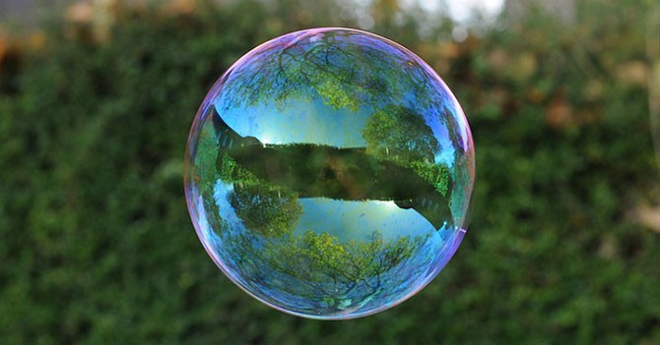 | Shoes and socks off and stretching all body parts  BUBBLES  - Blow bubbles, ask students to run around and burst bubbles by clapping both hands together to pop the bubble between hands  - Blow bubbles, ask students to stand still and burst a bubble by ‘poking’ using index finger on either hand
Arms & Shoulders  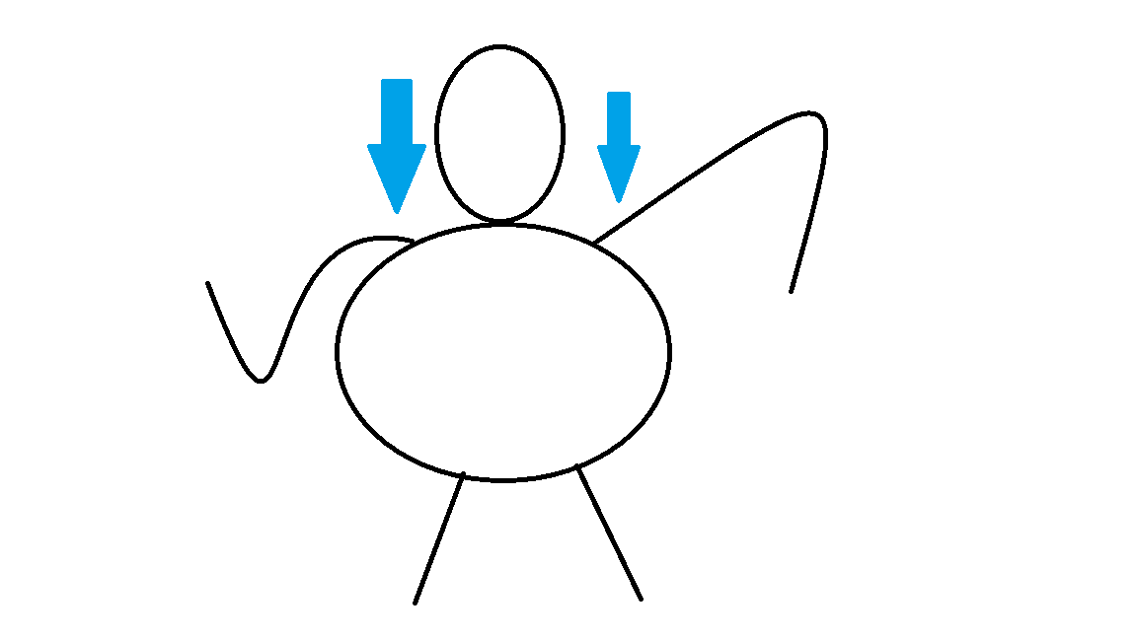 | PARCHUTE/ BLANKET  All students hold a part, place a small ball on the top  Ask Students to lift /tip their edge of the blanket to try to tip off the ball  Repeat with the blanket high or low  At the end ask the students to quickly lift the blanket up and down to try to bounce the ball off.
Core / Trunk  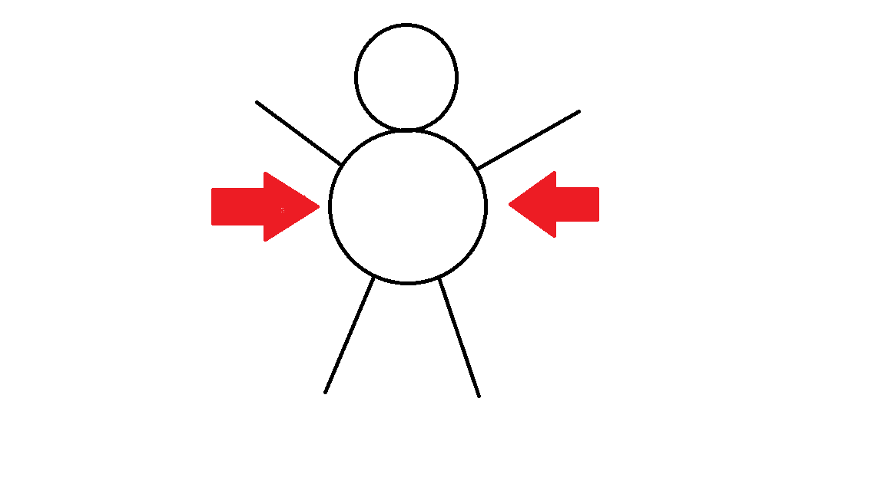 | 10 IN THE BED  Ask Students to lie in a line next to each other.  Place the blanket /parachute just over their feet  On ‘go!’ the Students race to sit up, reach the blanket and pull up over them and lie back down.  Repeat
Motor Planning  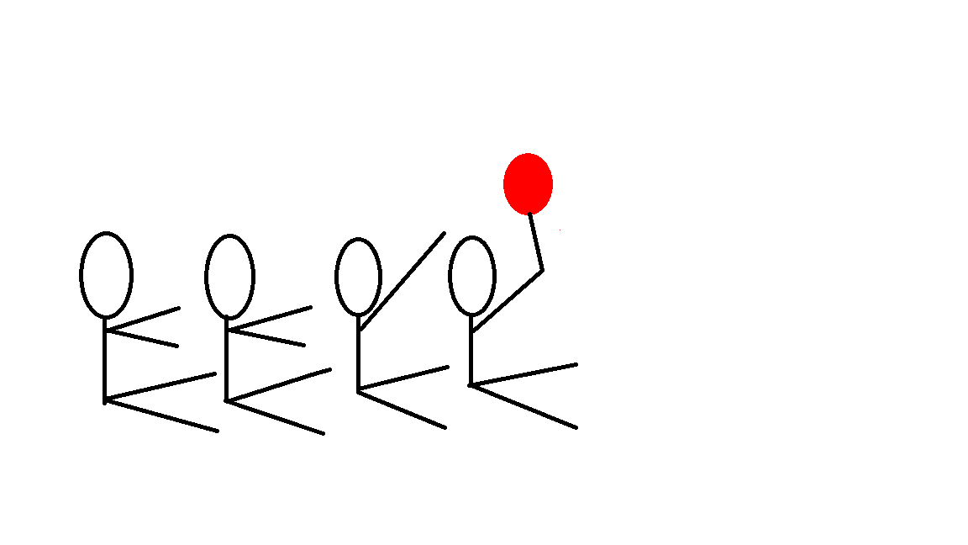 | UP AND OVER  Ask Students to sit long sitting behind each other  Student at the front pass the ball over their head to the Student behind them. When the ball reaches the last student-they stand up and run to the front and repeat.
Cool down  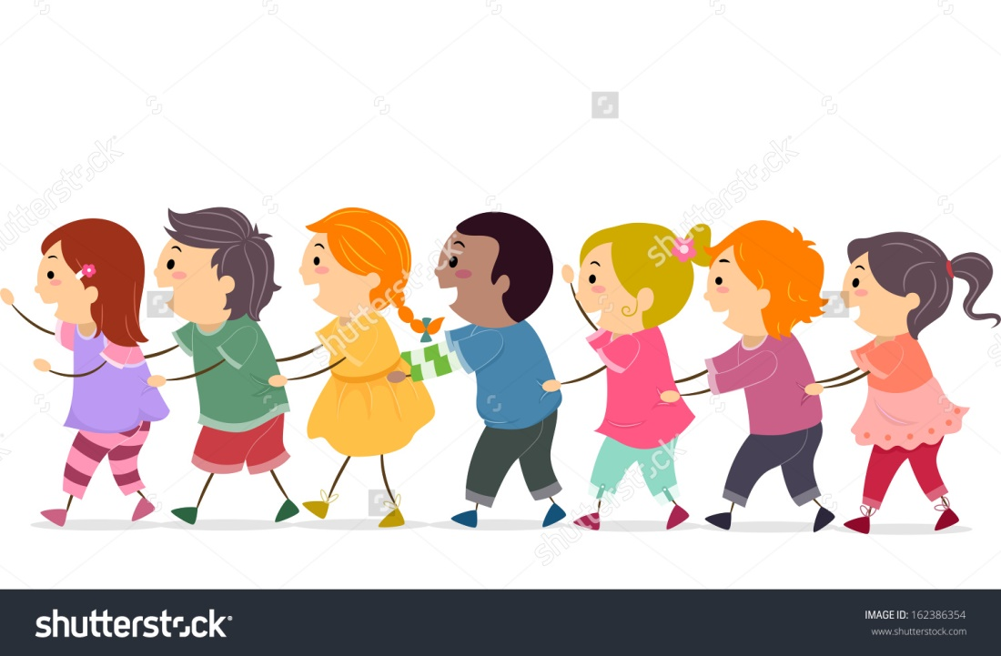 | THE TRAIN  Students to stand around the room.  The student who you feel has worked the hardest is named, they move around the room, collecting the other students on their ‘train’ (joined at waist). When all in a line, sit down in a circle and give each other a clap.

