Area | Activity | Student | Student | Student | Student
Warm up  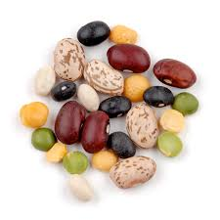 | Shoes and socks off and stretching all body parts  BEANS GAME  All move around the room and respond when different types of beans are called.  *Runner Bean * Jelly Bean * Frozen Bean
Arms & Shoulders  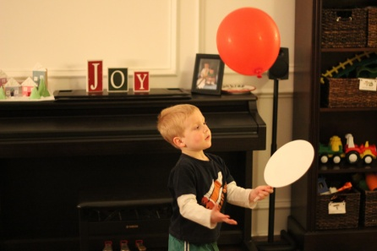 | BALLOON BADMINTON  Ask student to move into high kneeling position, hand them a racket and balloon and remind them not to sit back. Try to hit the balloon back and forth while maintaining high kneeling position.
Core / Trunk  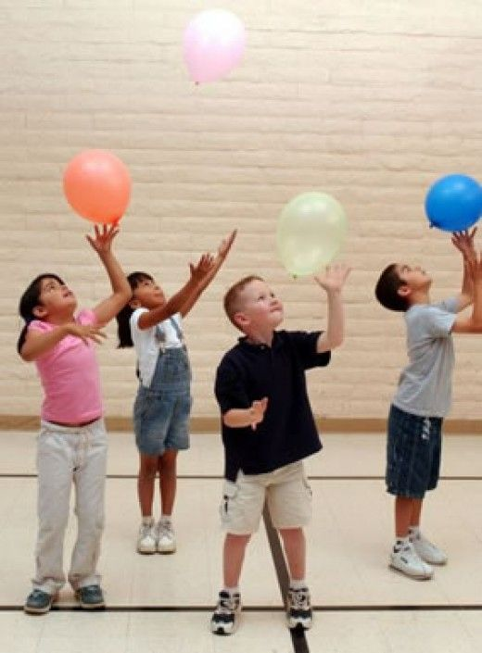 | BALLOON KEEP ME UP’S  Give the student a balloon - ask them to keep it up off the floor using every body part they have except their hands
Motor Planning  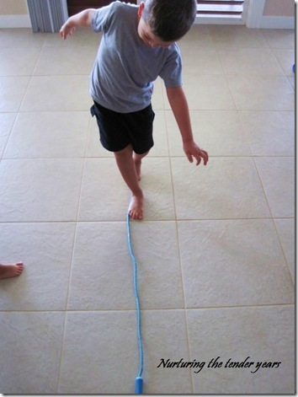 | WALKING THE LINE  Tape a straight line on the floor ( 5m +)  Ask students to walk along the line –ensuring their heel touches their toe  If the Student can do this, ask them to repeat backwards
Cool down | 1,2,3 Freeze  Students all sit in a circle around the Teacher  Teacher says ‘1,2,3 Freeze’ –everybody must stay still.  Each time they somebody moves, they are out until one person is left

