Area | Activity | Student | Student | Student | Student
Warm up | Shoes and socks off and stretching all body parts  THREE BLIND MICE  Tuck into each Student’s waist band a scarf or PE band. Students run around the room trying to collect the ‘tails’.
Arms & Shoulders  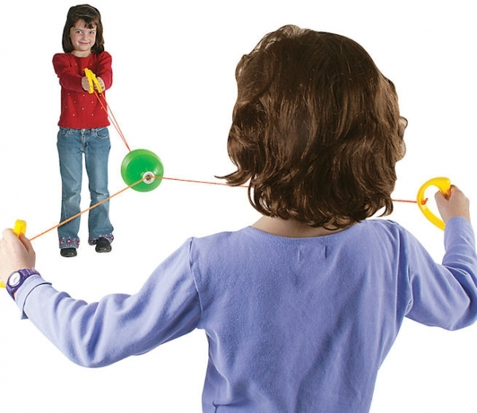 | ZOOM BALL in pairs  These can be purchased in Poundshops or Newbridge Outreach sells these too for £2 delivered.
Core / Trunk  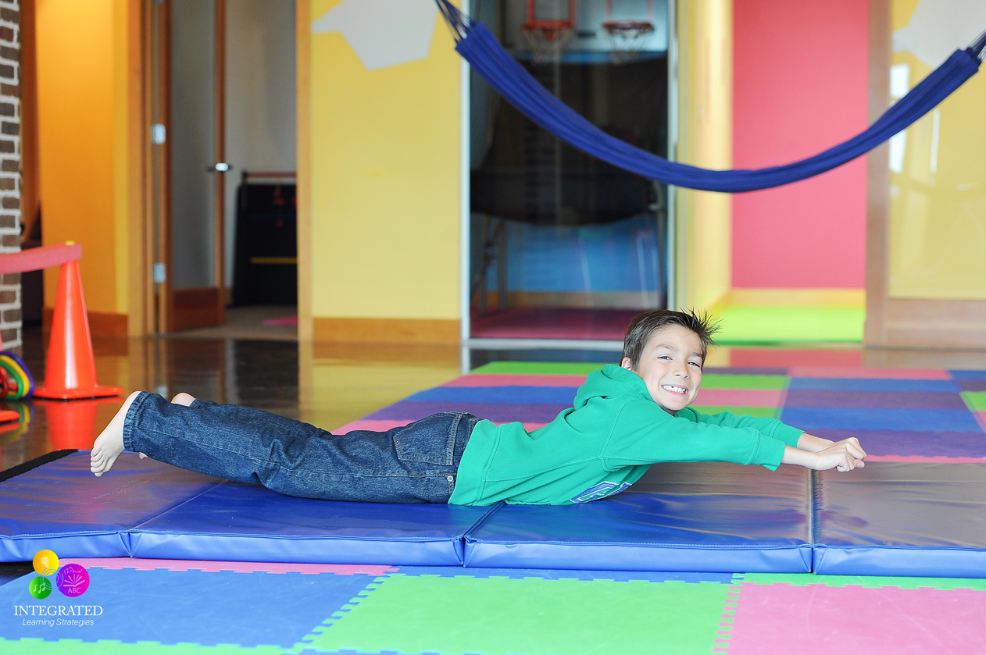 | SUPERMAN  Ask Students to lay down on the floor on their tummy, arms down by their side. Ask them to bring arms out by their side, head and chest up off the floor and if possible feet up.
Motor Planning  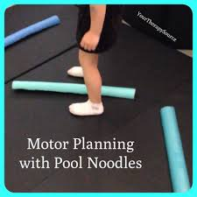 | NOODLE JUMP  https://www.yourtherapysource.com/videomotorplanningpoolnoodle.html
Cool down | WAKE UP CHILDREN!  Ask to Student rush around and stand still feeling their heart beat- ask them to comment –fast or slow?  Ask them to pretend to get ready for bed  Ask Students to lay down and pretend to be asleep for 1 min  Ask them to feel their heart beat and comment on the difference

