Area | Activity | Student | Student | Student | Student
Warm up  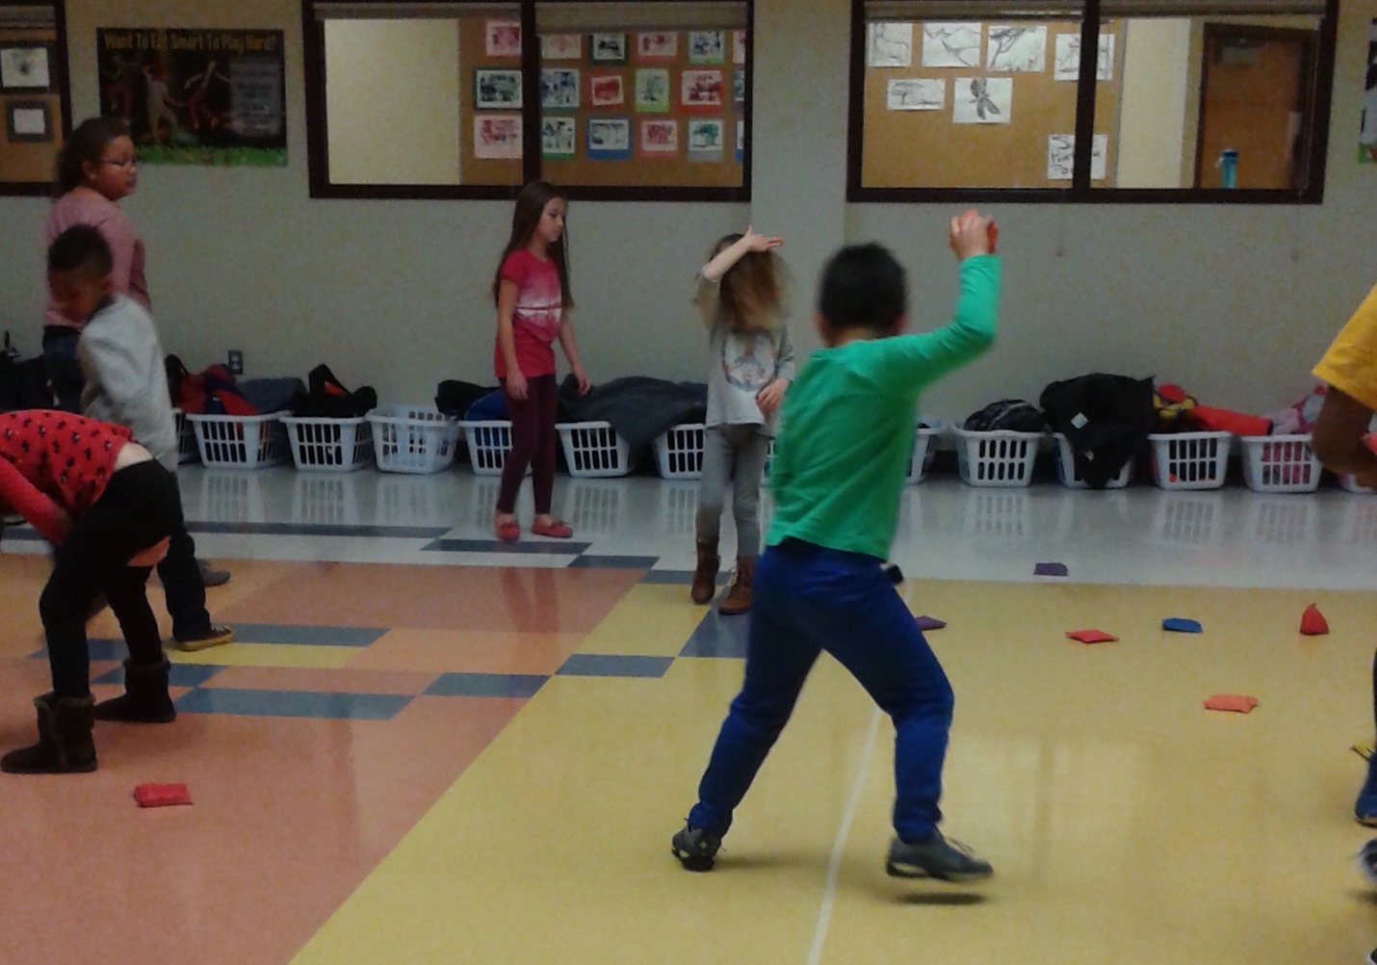 | Shoes and socks off and stretching all body parts  DODGEBALL  The Teacher to have a small soft ball  The Students to run around and the Teacher tries to hit them with the soft ball. Each time a Student is hit –they need to sit out.
Arms & Shoulders | WALL ARTIST  For each Student pin a large sheet of paper on the wall as shoulder height.  Mark on a simple rainbow shape.  Place a pile of pens/crayons across the other side of the room.  Ask the children to run across the room and choose a colour, run back to the wall and mark the rainbow shape. Repeat x 20
Core / Trunk  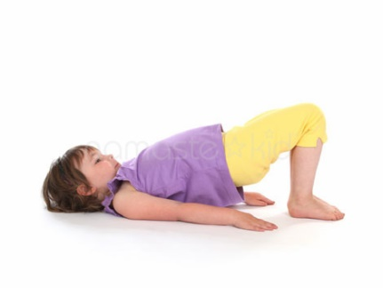 | BRIDGE  This is traditionally a yoga pose - try to extend the time a student can hold this position.  See if you can roll a ball through the gap made when in the bridge position.
Motor Planning | ANGELS IN THE SNOW  Have the child lie down on the floor and stand at his/her feet.  Point to the arm or leg you want he/she to raise.  Use various combinations i.e. left arm, right leg and then left arm, left leg. See if he/she can do it just by naming the body part.
Cool down  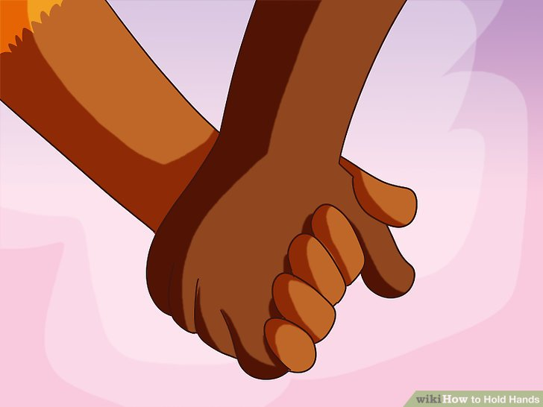 | PASS THE SQUEEZE Group forms a circle. Students hold hands with left hands turned upwards and right hands turned downwards to make a chain linking hands. They close your eyes breathing deeply and gently for at least five deep breaths. Teacher squeezes the left hand of one child who passes on the squeeze until it goes all around the circle

