Area | Activity | Student | Student | Student | Student
Warm up  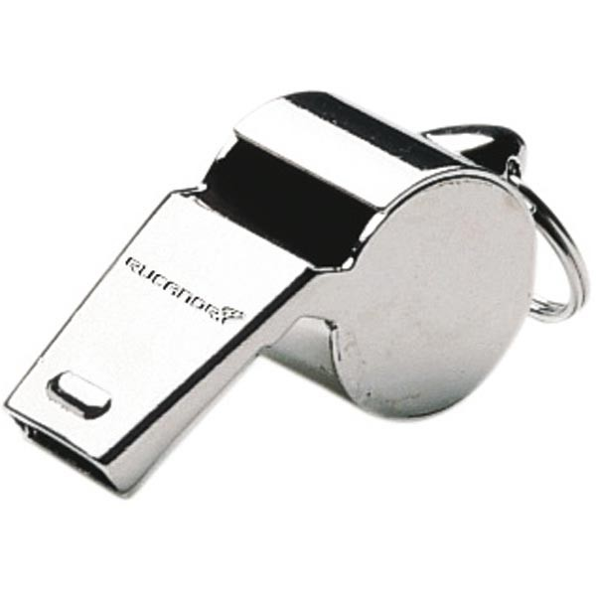 | Shoes and socks off and stretching all body parts  WHISTLE FREEZE  Teacher asks the children to walk, jog, or skip.  Children follow instructions but on hearing teacher blow the whistle, each child must freeze. If they move then, they must do five jumps.
Arms & Shoulders | FOUR POINT KNEELING  Position yourself on hands and knees, with hips over knees and shoulders over hands. Maintain this position, lift one arm out straight, replace.  While in four point kneeling position, lift one arm, pick up a bean bag and throw in the bucket. Repeat.
Core / Trunk  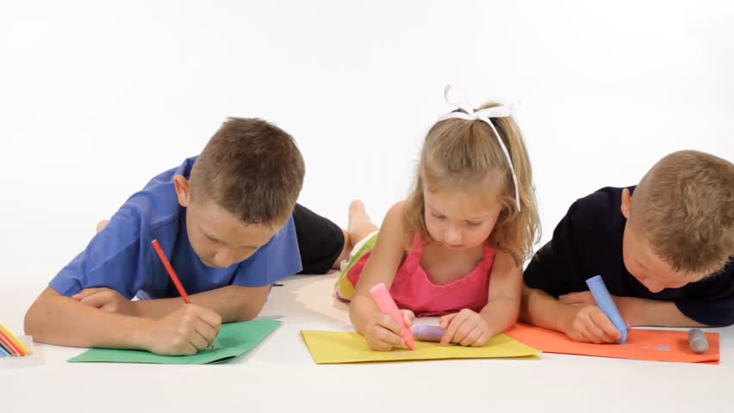 | TUMMY TIME  Ask a student to lay on their stomach and lift upper chest and head – encourage them to complete a writing/drawing task for 3-- 5 mins.  Do not let students lie their head down on hands/floor but encourage strength through their shoulders
Motor Planning  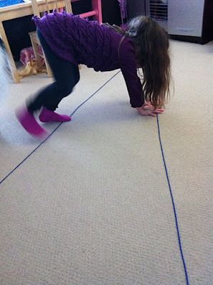 | TRIANGLE STRETCH  Mark out a triangle on the floor using tape  Ask students to start at the widest end and work towards the point.
Cool down | FROZEN BEAN BAG  Each child has a beanbag on his/her head. They move around the room. Hands must not touch the beanbag. If the bag falls off they must stay in that position until another child comes to help by picking up the beanbag and replacing it.

