Area | Activity | Student | Student | Student | Student
Warm up  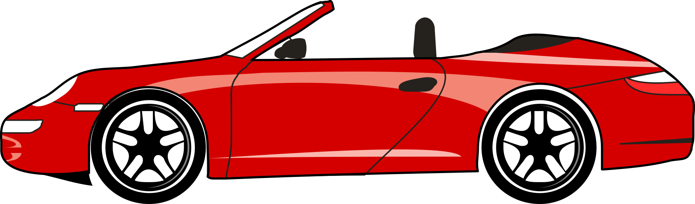 | Shoes and socks off and stretching all body parts  TOP GEAR  Children are asked to imagine that they are driving a car and as the teacher calls out the various gears the children must accelerate or decelerate depending on the gear that is called. All children start travelling around the play area in first gear which is walking and get progressively faster up to running at a brisk pace for fifth gear.
Arms & Shoulders  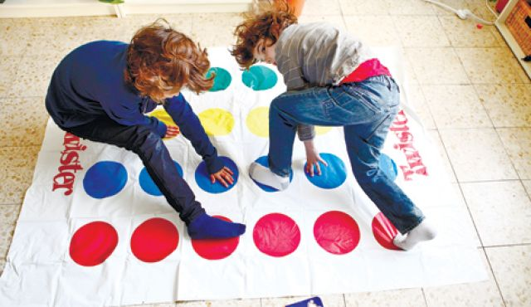 | TWISTER
Core / Trunk  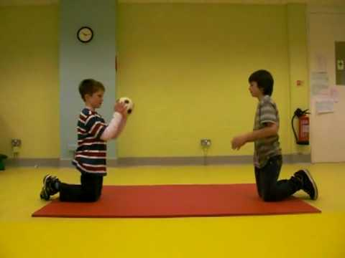 | THROW AND TOSS  Ask the student to remain in high kneeling position. Give them a set of balls/bean bags and ask them to try to throw into a bin from this position. Expect the student to remain in high kneeling and not to rest back on their heels
Motor Planning  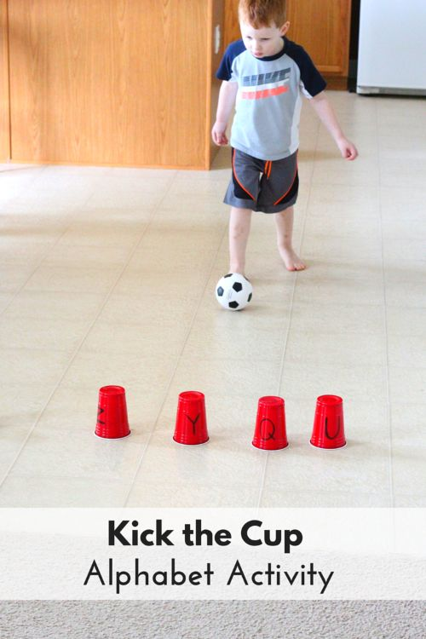 | KICK A NUMBER / LETTER  Mark a few plastic /paper cups with numbers or letters the Student knows  Ask the Student to stand back and kick a ball to knock over the requested letter or number.
Cool down  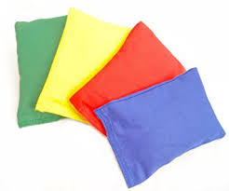 | SHHHHHH !  The children stand or sit with their eyes closed or place a hand over their eyes. The teacher selects one child who tiptoes around the area lightly touching each child in turn. When tipped the child opens the eyes and moves slowly and quietly to the door to line up. If the children are successful in remaining very quiet the last child should not know they are the last one until s/he opens his/her eyes

