SENSORY APP’s
Fluid Monkey |  | A cool app and its free !  There are 8 different display option – very relaxing to explore for children and parents alike !
Gravitarium |  | Ideal app to help you calm down
Awesome |  | Lots of different speeds and designs
Fireworks Arcade |  | Loved by children and adults alike.
Ooze | 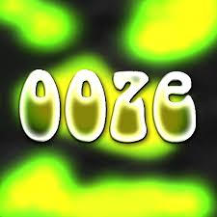 | One of the first sensory app’s but still very engaging.
Reactickles |  | Good for cause and effect and tracking.
Sensory Just Touch  Sensory Megma |  | Old fashioned lava lamp in your ipad.
Sounds of the House-  Autism Series |  | Very simple but a good way to develop noise tolerance and vocabulary
Soundscape |  | Very clever app- take a song the student likes and it will play picking up a visual stream.

BEHAVIOUR/ REWARD APP’S
Tap me happy | 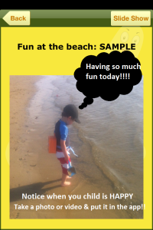 | Tap Me Happy is a virtual happy place for kids with Autism and other special needs – developed for both iPhone & iPad.
Tantrum Tracker | 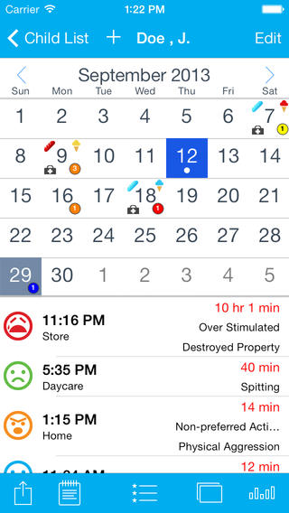 | Tantrum Tracker was designed to make tracking tantrums and outbursts for children on the autism spectrum, children with ADD or ADHD (or any child with behaviour control issues) easy, through a logical work flow and organization of "tantrum" data, photo and video media, and visual representation of data via charts and graphs
Present a choice | 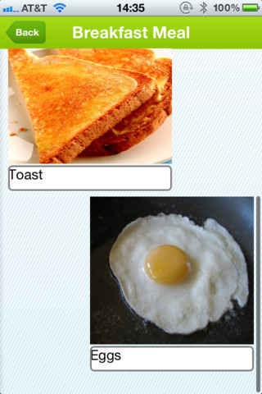 | The app gives you the ability to create choices for the child with picture cues. You can add your own text and pictures
Wait for it timer |  | Wait 4 it is a great visual tool if the student has understanding of PEC’s.
Model Me  Going Places | 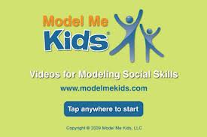 | Model Me Going Places™ is a great visual teaching tool for helping your child learn to navigate challenging locations in the community. Each location contains a photo slideshow of children modelling appropriate behaviour.
First and then |  | A good visually simple app that is easy to use to provide a portable schedule when you are out and about.
My Life Skills Box | 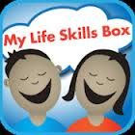 | A free app visually showing everyday situations and acceptable ways to deal with them.
Social Stories Creator | 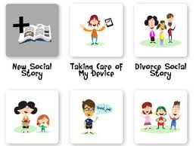 | A great app for creating educational social stories and sharing memories.
Too noisy | 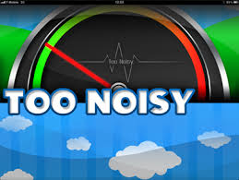 | There are lots of these app’s around – this is my favourite and its free !
FINE MOTOR
Bugs and buttons | 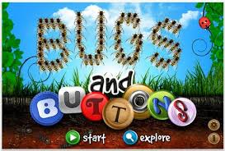 | Currently my favourite app for fine motor and learning skills  Lots of variety each time you play and provides a slowly increasing challenge.
Dexteria |  | Designed by OT’s  Divided into 3 sections;  - Tap It- isolating fingers and tapping  - Pinch it- pinch crabs using pincer grip  - Write it-Letter and Number formation  If this is too difficult there is an early years version.
Finger count | 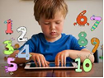 | This is an unusual app. It starts with a blank black screen, each time you touch the screen with a fingertip it marks a number, adding on each time it is touched again. If you touch with 3 , 4 , 5 finger tips in one go, it will jump up by 3,4,5 etc. Time how long it takes a student to get to 50 or 100 – tell students if you use more fingers you will reach the target number quicker.
Mazing |  | Good graduation between levels, visually clear mazes to trace with fingertip.
Sam Phibian | 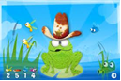 | Fun clear animation  Feed the frog by touching and dragging.  Made more complex by following instructions of what to feed the frog.  Very appealing to children.
Wow! Doodle | 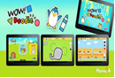 | A great fine motor package of activities for student to try- visually fun and cartoon looking.
Alien Buddies | 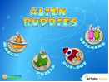 | A variety of visual motor and visual perception tasks.
Clicky Sticky |  | Use drag and drop skill to create a variety of scenes- a nice way to end the session.
Balloons |  | Lots of nice challenges followed by fun rewards
Little digits | 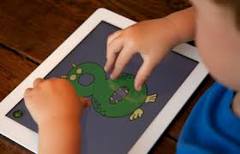 | A clever app that asks you to engage all your fingers.

FUN
My own puzzle | 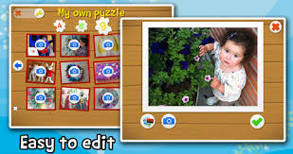 | There are lots of these type of app’s  I like this one as it allows you to use your own photo’s too
Toca’s kitchen |  | Simple sequential and easy to access- there is a wide range in the Toca range – worth a look
Vid Rhythm |  | Free and great fun

SIMPLE LEARNING
Clicker docs  Clicker sentences |  | App version of Clicker – cheaper and accessible version of PC software
My first app’s – Build it up |  | Visually clear and easy language
Early Counting Skills-  Autism Series | 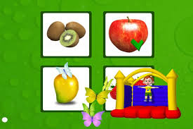 | Worth checking all the Autism Series as a good range now
Special Stories | 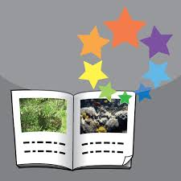 | Special Stories – very popular with lots of SEN children

Clair Warner
October 2013

