Can you list 6 things you did before you came to school today?
What did you do? | Did you need help?
Look at the two pictures, and decide if either or both of the Students would be able to / or need help to do the tasks listed.
 | 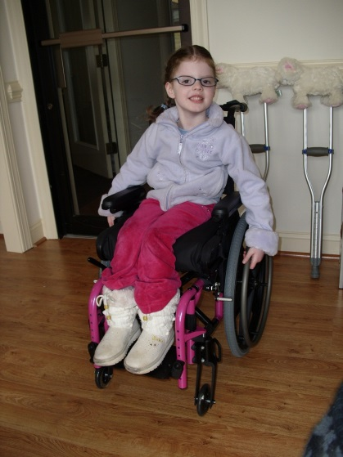  Georgina | 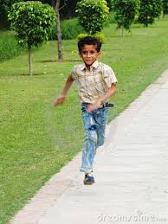  Kamal
Make their breakfast
Get out of bed |  | Appendix 2
Clean your teeth
Get dressed
Ride a bike to school
Take themselves from playground to class
Write a story

