Boy  Roald Dahl | 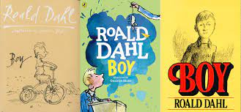 | ENGLISH

Look at the War Horse section on our website- here you will find created examples of all ideas listed below. This will visually demonstrate how to simply and set out tasks/ information.
http://redbridgeserc.org/resources/category/war-horse

Focus | How | Resource | Further links
Concepts to focus on | Concept of Autobiography ‘All about me’  - Mini project to start this topic ‘All about me’ – each student built a profile of likes/ dislikes/ family, hobbies, interests etc.  - Introduce concept of Autobiography – another person talking/ writing about themselves  - Students create mini presentations to give to peers and larger class  - Introduce ‘Boy’ – explain this is a man called Roald Dahl talking about himself when he was growing up  - Group research – what other books did Roald Dahl write – brainstorm and create a display of the books he has written (films clips too) | All about me https://www.teachitprimary.co.uk/resources/f/all-about-me/this-is-me/33127  https://www.teatimemonkeys.com/all-about-me-printable-book/  All about me -emotions  https://littleowlsresources.com/all-about-me
Timeline and passing of time/ history | - Create timelines- growing up  - Photos of themselves different ages -order  - Encourage students to talk through memories linked to photos- link to them ‘writing’ an Autobiography  - Record using Book Creator or Video the students talking about their photos | 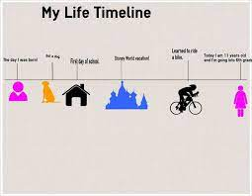 | 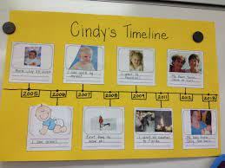
Introduce the story/book | Simplified picture version of the book. | Summary of story  https://study.com/academy/lesson/boy-by-roald-dahl-summary-quotes.html  https://www.gradesaver.com/boy-tales-of-childhood
 | Video of chapters of the book  Use You Tube clips of the film for real life settings and segments of the story | Video’s of chapters of the book  https://www.bbc.co.uk/bitesize/guides/z2rfg82/video  https://www.bbc.co.uk/bitesize/clips/ztvpyrd  https://www.bbc.co.uk/bitesize/clips/zfcvr82
Elements to focus on; | - Sweet shop and tricks  - Norway -going on holiday – differences of visiting another town or country  - Boarding school – what would happen if you had to sleep at school?  - Writing letters home to Mother  - Love of photography – photo diary  - Africa  - WW2 linked to work with War Horse | See individual brain storm mind maps
Introduction of key vocab | Introduce characters and key vocab for each week’s chapter – vocab bingo added weekly.  Students tick off as they hear or see key words, while watching the film clip | Vocab Bingo Sheet – key words/ pictures can be changed for each segment taught | War Horse Bingo Sheet
 | Match/ Snap / Lotto with vocab cards. Print off x 2 Bingo cards and cut up to make key word games | https://www.senteacher.org/printables/freeworksheets/30/Word-Bingo-Game-Card-Maker.html (FREE) | Paid sites offer quick and easy tools  Widgit  Subscription to Widgit – online single access is cheapest  https://www.widgit.com/products/widgit-online/index.htm- currently offering a free trial  Twinkl
 | Picture Dictionary  At the beginning of a new topic- provide each student with a blank exercise book- divide up a-z to create personalised dictionary. Stick in pictures, symbols, key words as they are learnt throughout the topic | 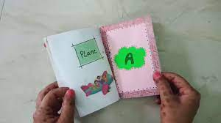 | https://www.youtube.com/watch?v=oDPSF7zZVCM
 | Memory  Key vocab entered into Matching cards -pairs – students play pairs on app to reinforce key vocab | www.matchthememory.com(FREE) or Memory Apps Memorama or Matching Pairs!
 | Match the word to symbol | See War Horse word-symbol matching sheet | Widget online
Descriptive sentences | Colourful Semantics sentences to develop sentence structure | See War Horse sentence sheet to demonstrate | Clicker sentences  Widgit
 | Transfer the sentences composed into Powerpoint  – copy type sentence (to build a story)  Over a period of weeks, adding 1-2 sentences a week the student will all have a PowerPoint summary of the story, they can voice over or share with class.  Students can use the facility to record over each slide and ‘narrate’ their version of the story.  Images selected from google search-students encouraged to put in initial letters of google search or use Alexa or siri to search images (giving instructions) | See example of War Horse Powerpoint created over a term. | Powerpoint – 365 access facilities allow students to dictate and record over each slide.  Teach students to use siri when searching the Internet.
Handwriting key words/ phrase | Use FREE handwriting worksheet generator  You can create personalised handwriting sheets – initial letters, key words or short sentences | See War Horse Handwriting example | https://www.senteacher.org/printables/Literacy/52/HandwritingSheetMaker.html
Story building | App – Book Creator  https://www.youtube.com/watch?v=HJvkeh7DK6c  Staff can add in images- students can order, use voice dictation, type simple sentences to create their own version of a story | 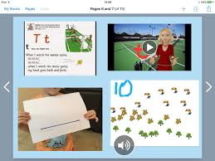 | Story/ book creator app’s are the most engaging way to develop story composition
Phonics – initial letter sounds linked to key vocab | - Sorting key vocab with initial letter sound  - Building a sound wall. Alphabet wall on wall of hub. Each week students add key vocab to initial sound – evolving language wall.  - CVC words using key vocab eg man, gun  - CCVC words  - CVCC words | - See War Horse initial letter sound sheet  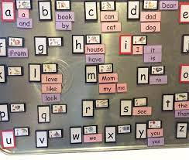 | CVC Wheel  https://www.easypeasyandfun.com/cvc-word-wheel/
Larger context -The War | Before starting a new book- decide one or two key features or context you would like to focus on (concrete as possible) | - See WW1 Pack
Talkabout sheet | Each week create a Talkabout board – laminate and leave on the table  Adults and students identify as many pictures as possible and talk about what they are to class.  Makaton to support symbols if required | See -War Horse Talkabout board  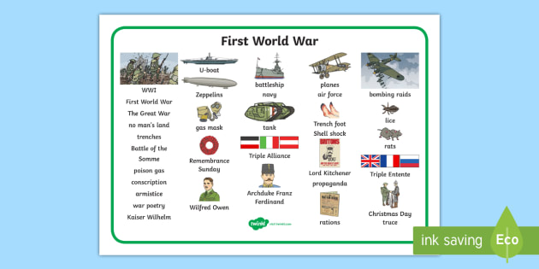
Overlearning | Precision teaching -key vocab  Create Quizlet to take home. Pictures to words | SEaTSS Video explaining to staff how to use Precision Teaching  https://www.youtube.com/watch?v=ZPuBIj53yfc  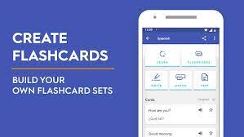 | https://quizlet.com/en-gb
Craft activities to support language development | - Simple animation  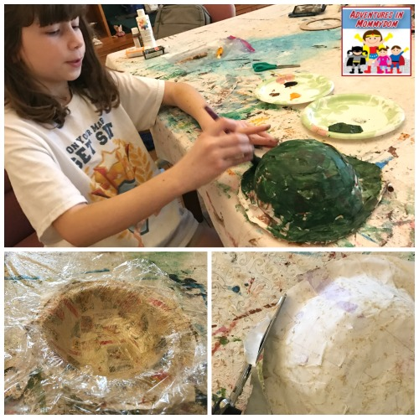 | War Horse example  https://www.youtube.com/watch?v=Ir8T0GSPpEE  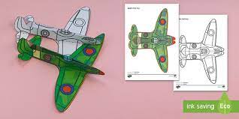  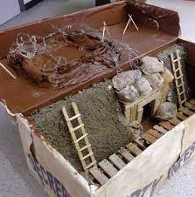
Sharing with the Class | - Craft activities – student talking through key parts using key vocab  - Story created on book creator  - Powerpoint Presentation with simplified story  - Character described using Clicker sentences/ Clicker books  - Student could create a simple picture quiz on Powerpoint – small part of a picture shown ie horse ear and encourage the students to share with class as a fun activity. | 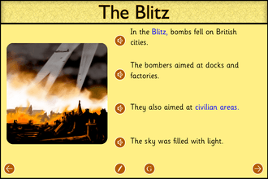 | Clicker sentences app or software  https://www.cricksoft.com/uk

