CEREBRAL PALSY

Key facts
- This is a non – progressive disorder of movement or posture caused by a malfunctioning of, or damage to the brain.
- Cerebral palsy can be caused by infections, rubella and compression of the brain in
pregnancy, prematurity, diseases such as Meningitis, brain tumours, accident or blow to the head, drowning, or lack of oxygen.
- 3 in 1000 children have a degree of Cerebral palsy.

Types of Cerebral Palsy
There are three main forms of Cerebral Palsy-
- Spastic Cerebral Palsy
- Athetoid Cerebral Palsy
- Ataxic Cerebral Palsy.

Cerebral Palsy can affect one or more limbs – this is described as
Hemiplegia – upper and lower limb on same side
Diplegia – major involvement of lower and minor involvement of upper limbs
Monoplegia – one limb involved
Quadriplegia – all four limbs affected
Paraplegia- lower limbs only
Monoplegia indicates that the Cerebral Palsy only affects one limb.

Other associated difficulties that could be linked
- Visual impairment
- Hearing impairment
- Epilepsy
- Oral dental- swallowing and dribbling
- Continence

Educational implications
Difficulty with handwriting and recording
Perception – visual discrimination, tracking, spatial awareness
Memory – auditory memory and sequencing
Mobility
Independence
Organisation
Personal care/ dressing / feeding
Sensitivity to noise- startle reflex causing pupils ‘jump’ in response to loud noises.

Useful addresses and web links

http://www.scope.org.uk/help-and-information/education

Scope is a Registered Charity established in 1952. It provides information and support to children and adults with cerebral palsy, people living with other severe and complex impairments and their families.

Recommended resources from Scope site;
Imagine the difference – KS1 & KS2 resource to celebrate difference
Speaking for ourselves- KS 3& KS4 – history of people with cerebral palsy.

Family support
https://www.scope.org.uk/support/services-directory/emotional-support-parents-barking
Face 2Face Free befriending service

Teenagers
https://www.scope.org.uk/support/services-directory/transition-adulthood-waltham-forest
Students aged 14-17 yrs with complex needs

Youth Club
https://www.scope.org.uk/support/services-directory/group-activities-young-people-waltham-forest
Age 13-17yrs Saturday Club

http://www.epcpspurs.co.uk
EPCP Spurs is a football club for players with cerebral palsy. The club is open to all ambulant players with cerebral palsy aged between 6 years to adults. Both boys and girls are welcome to join the club.
Age range 6 years to 99 years
Address Emerson Park School, Wych Elm Road, Hornchurch, Essex, RM11 3AD
Tel 01708 475 285
Email info@epcpspurs.co.uk

Frame Football
Simply google’ Frame Football Basildon’ and the Facebook page will appear.
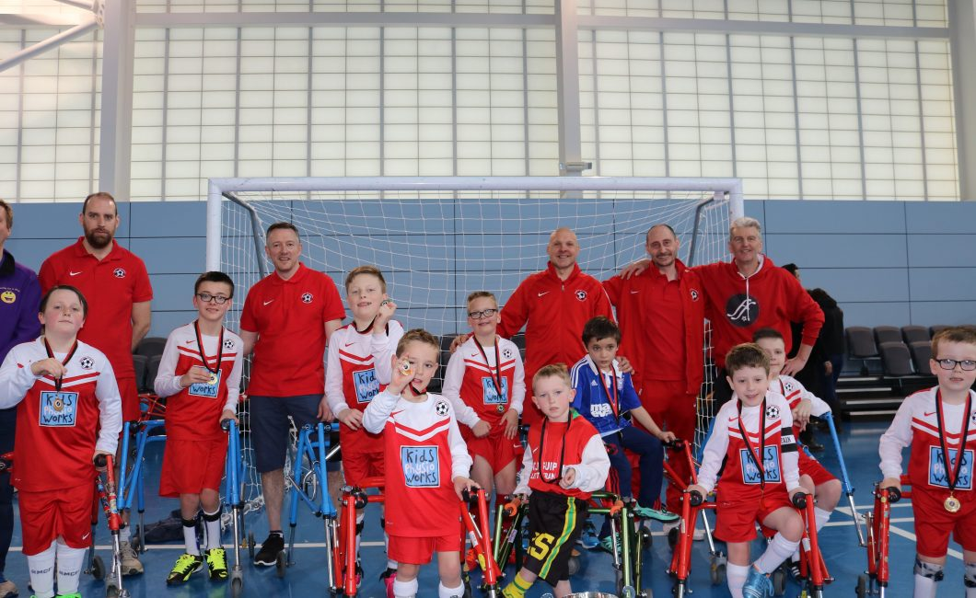
http://parachatter.com/tag/basildon-soccability-frame-football/

http://www.snapcharity.org/
Special Needs and Parents (SNAP) supports Essex parents of children who have Special Needs or a disability.
SNAP have a helpline 01277 211300 Mon- Friday 8.30am - 5pm.
SNAP has an extensive library of over 2,000 specialist books, hundreds of quick and easy reference information sheets and over 250 specialist videos and DVDs.
The SNAP Centre, Pastoral Way, Warley, Brentwood, Essex CM14 5WF

LINKS TO YOU TUBE- Cerebral Palsy
http://www.youtube.com/watch?v=p5VNdy7_nIM
4 min video clip from Great Ormond Street explaining the key facts.

http://www.youtube.com/watch?v=dsXlPdipR5Q
Film showing a 15 yr girl called Hannah. Hannah has complex cerebral palsy and this film shows her daily life.

http://www.scope.org.uk/support/disabled-people/trendsetters
Video blogs made by young people with Cerebral Palsy

https://www.youtube.com/watch?v=DbXyljItrIw&list=PLEJWI99Hx3tHR74i1q3uQYmljcCFIQZAG&index=2
Bullying from a young person’s perspective.

https://www.youtube.com/watch?v=Qu-G9rz7p8U
SELECTIVE dorsal rhizotomy

http://www.youtube.com/watch?v=5Co5JwOcGfU&feature=related
A mix of lots of images of different people with Cerebral Palsy.

http://www.youtube.com/watch?v=lFMLL6A7K0U&feature=related
This clip shows Josh Blue, who is a comedian with Cerebral Palsy.

