Study Skills Handout.
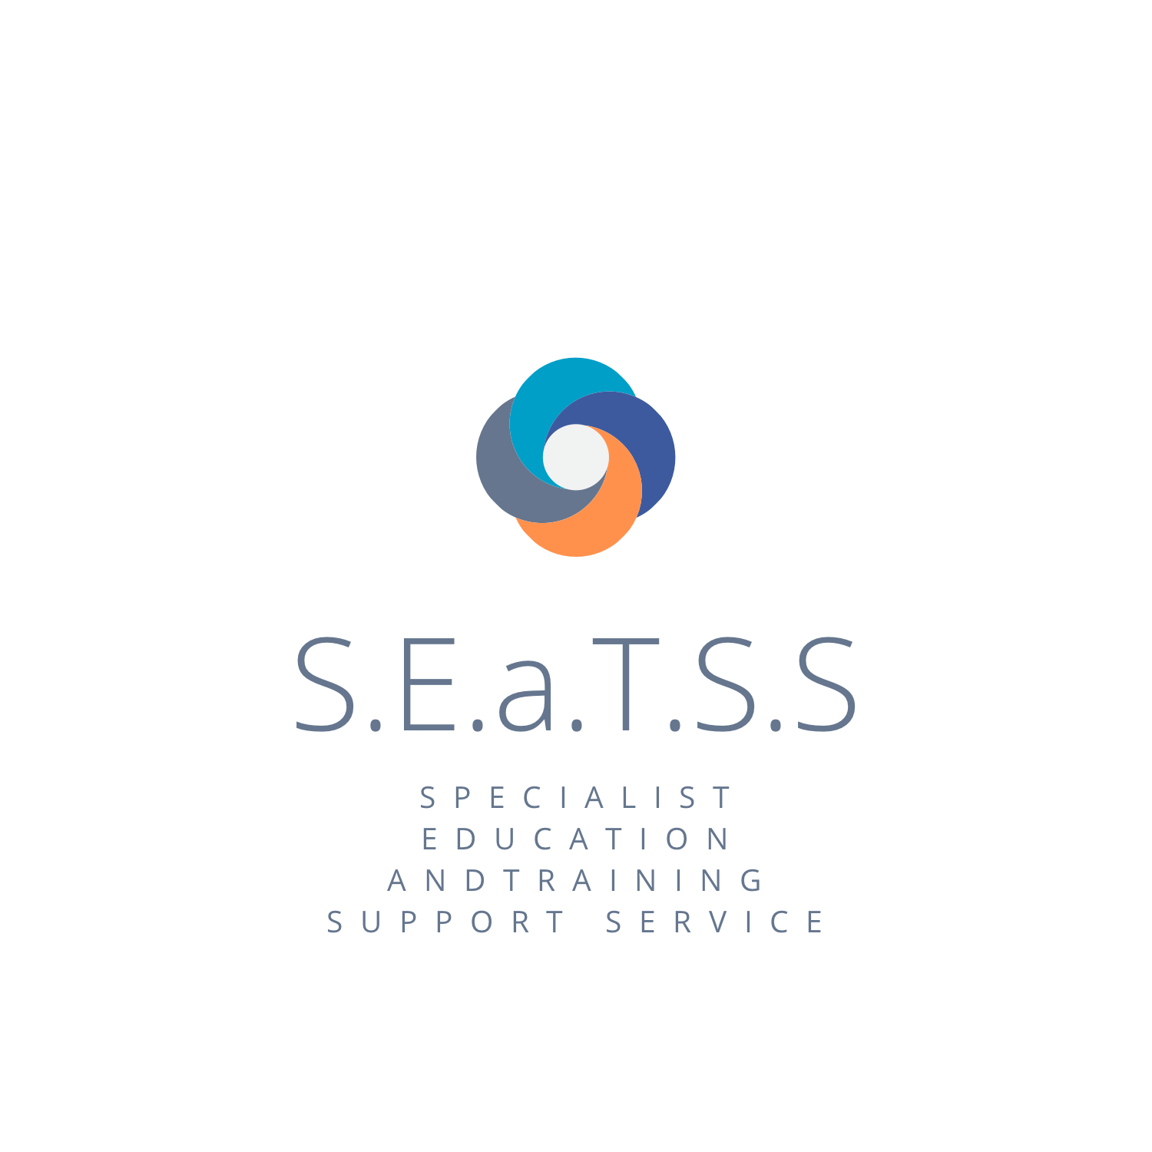

This handout accompanies the SEaTSS parents SEND conference 11/06/2022
Please use it to find 3 or 4 different ways to help your child to study and revise.
It is not intended that you use every method or website as this would be overwhelming.

Mindmaps:
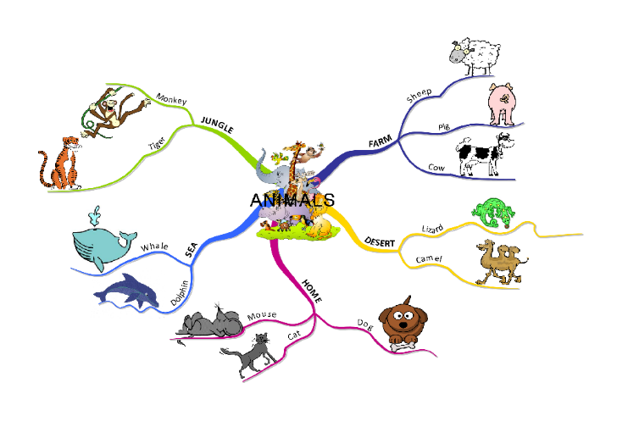
- Mindmapping complements the way that both sides of the human brain works
- Mindmaps help children to organise and sequence their thoughts in a logical and systematic order and to be creative and make links
- They are a great visual tool that your child can use to help them to organise and categorise their notes

- They enable children to condense notes
- They encourage them to develop their ideas and stimulate thoughts
- They can help them to link ideas
- You should encourage your child to personalise it with things such as colour coding to make it meaningful to them

https://getrevising.co.uk/make/mindmaps
https://youtu.be/oY4sUQzXJ1g
https://vm.tiktok.com/ZML7YG53N/

Mnemonics
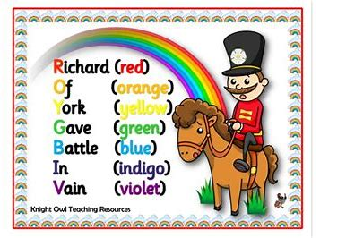
A long word that means using the first letters of something hard to remember to make a sentence that is easy to remember. This aids the person to recall the hard stuff.

Flash cards: It can be fun to create these cards the ‘old fashioned way’, with card, pens and colours.
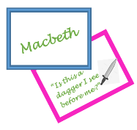
8 Better Ways to Make and Study Flash Cards (collegeinfogeek.com)Learning tools and flashcards - for free! | Quizlet
How to study flashcards using the Leitner system - YouTube
leitner system (how to memorize more efficiently!) - YouTube
But there are also lots of apps out there…..
Anki
Flashcard App
AnkiApp - The best flashcard app to learn languages and more.

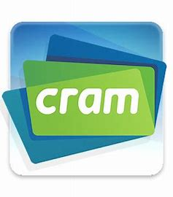
Online flashcard websites.
Cram.com: Create and Share Online Flashcards

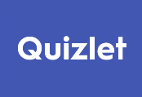
https://quizlet.com

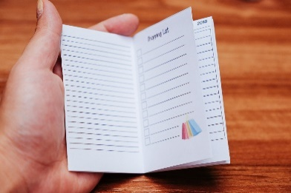
PocketMod – creates small booklets. Your child could create some revision booklets that can then be carried in a small bag/pocket etc.
http://www.pocketmod.com/
https://www.youtube.com/watch?v=rmcYYdiWGPU

Post it notes
- Good for visual learnings because different colours can be used to represent different ideas so helps memory
- Can be stuck around the house as a quick prompt. Put them in prominent such as the fridge
- Good for making notes and sticking in books
- Can help to sequence ideas and physically move ideas around

https://youtu.be/hc-qV_a75pc
How to use post-it notes for revision (lifemoreextraordinary.com)
2 New Ways to Use Sticky Notes // 2 Minute Study Tips - YouTube

Source Analysis Questions
- Very useful in some academic subjects such as history, geography, English.
- The student analyses text with these questions
- Helps break the task down and categorise

- Past exam papers
- Get information on what EXAM BOARD is being used for different subjects from the school
- Help your child to become familiar with what exam papers in their subjects look like
- Point out the important information on the front page such as the timing
- Go to the exam board website to look at past exam papers and past questions
- Encourage your child to practise past exam questions on a topic after they have revised it

www.aqa.org.uk
https://qualifications.pearson.com/en/support/support-topics/exams/past-papers.html
Past GCSE Maths Papers (FREE) - 2022 Topics - Third Space Learning
Revision | Collins GCSE Revision | Download Free Exam Papers Resources
AQA | Find past papers and mark schemes
Maths Genie - Free Online GCSE and A Level Maths Revision
Past papers | Past exam papers | Pearson qualifications Edexcel

Don’t forget – some of the other strategies
- Creating a timetable
- Taking breaks
- Moving around
- Silly rhymes
- Music

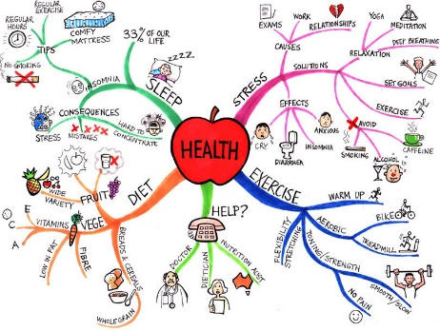
Health: It is important to help your child look after their health during the revision and exam period. You can break this down into different areas to help them manage this. EG. Sleep/Diet/Stress/Exercise and where to get help if needed.

Have a look at a couple of the many support websites out there.
Mindfulness - NHS (www.nhs.uk)
Mental Health Resources for Exams | YoungMinds
Can food improve your exam performance? - BBC Food

Some other great resources that we didn’t have time to let you know about in the presentation
The student room
https://www.thestudentroom.co.uk/forum.php
https://www.thestudentroom.co.uk/g/make Free resources in the student room
https://getrevising.co.uk/planner more resources from the student room

BBC Bitesize
Voice dictation
https://itunes.apple.com/us/app/simply-voice-dictation/id791425447?mt=8

Google Dictation software recommended for longer pieces of writing
If a Student has access to Google Docs, there is free software built in allowing them to dictate while the computer types
Here is how to access this FREE:
https://bit.ly/2qT0tr9
https://bit.ly/2hrqInO
https://www.youtube.com/watch?v=UY9MeKd5gRI

GOOGLE CHROME EXTENSIONS
Free software for Chrome (most popular way of searching the Internet)
chrome://apps/ -> Web Store -> Extensions-> Select and Speak
Here is how to use it
https://www.youtube.com/watch?v=GdY1CpS1CH4
Select and Speak enables a Student to select information on a webpage and have it read back

Dyslexia Reader Chrome Extension
Free Software extension which can be used in Chrome to change the format of any webpage into a Dyslexia friendly format (Open Dyslexic)
https://www.youtube.com/watch?v=csHlhu8gcYA

The Revision App
As you complete revision tasks you win arcade games as prizes- ideal for the gamer students needing rewards
https://www.youtube.com/watch?v=wn3KtheuIOs&t=87s
https://apple.co/2HCRqoT

You Tube
There is a new generation of resources now on You Tube with a huge number of ‘how to’ videos, with ideas for revision, there’s bound to be something useful.
Songs created by Teachers/ Students to help remember key facts:
Physics Revision Song
https://bit.ly/2vBFBKz
Macbeth Quotes Rap –‘ Mac’s Not Hot’
https://bit.ly/2F7kyPN

Call Scotland iPad Apps for Learners with Dyslexia

New and Revised Ipad App Wheels (callscotland.org.uk)

