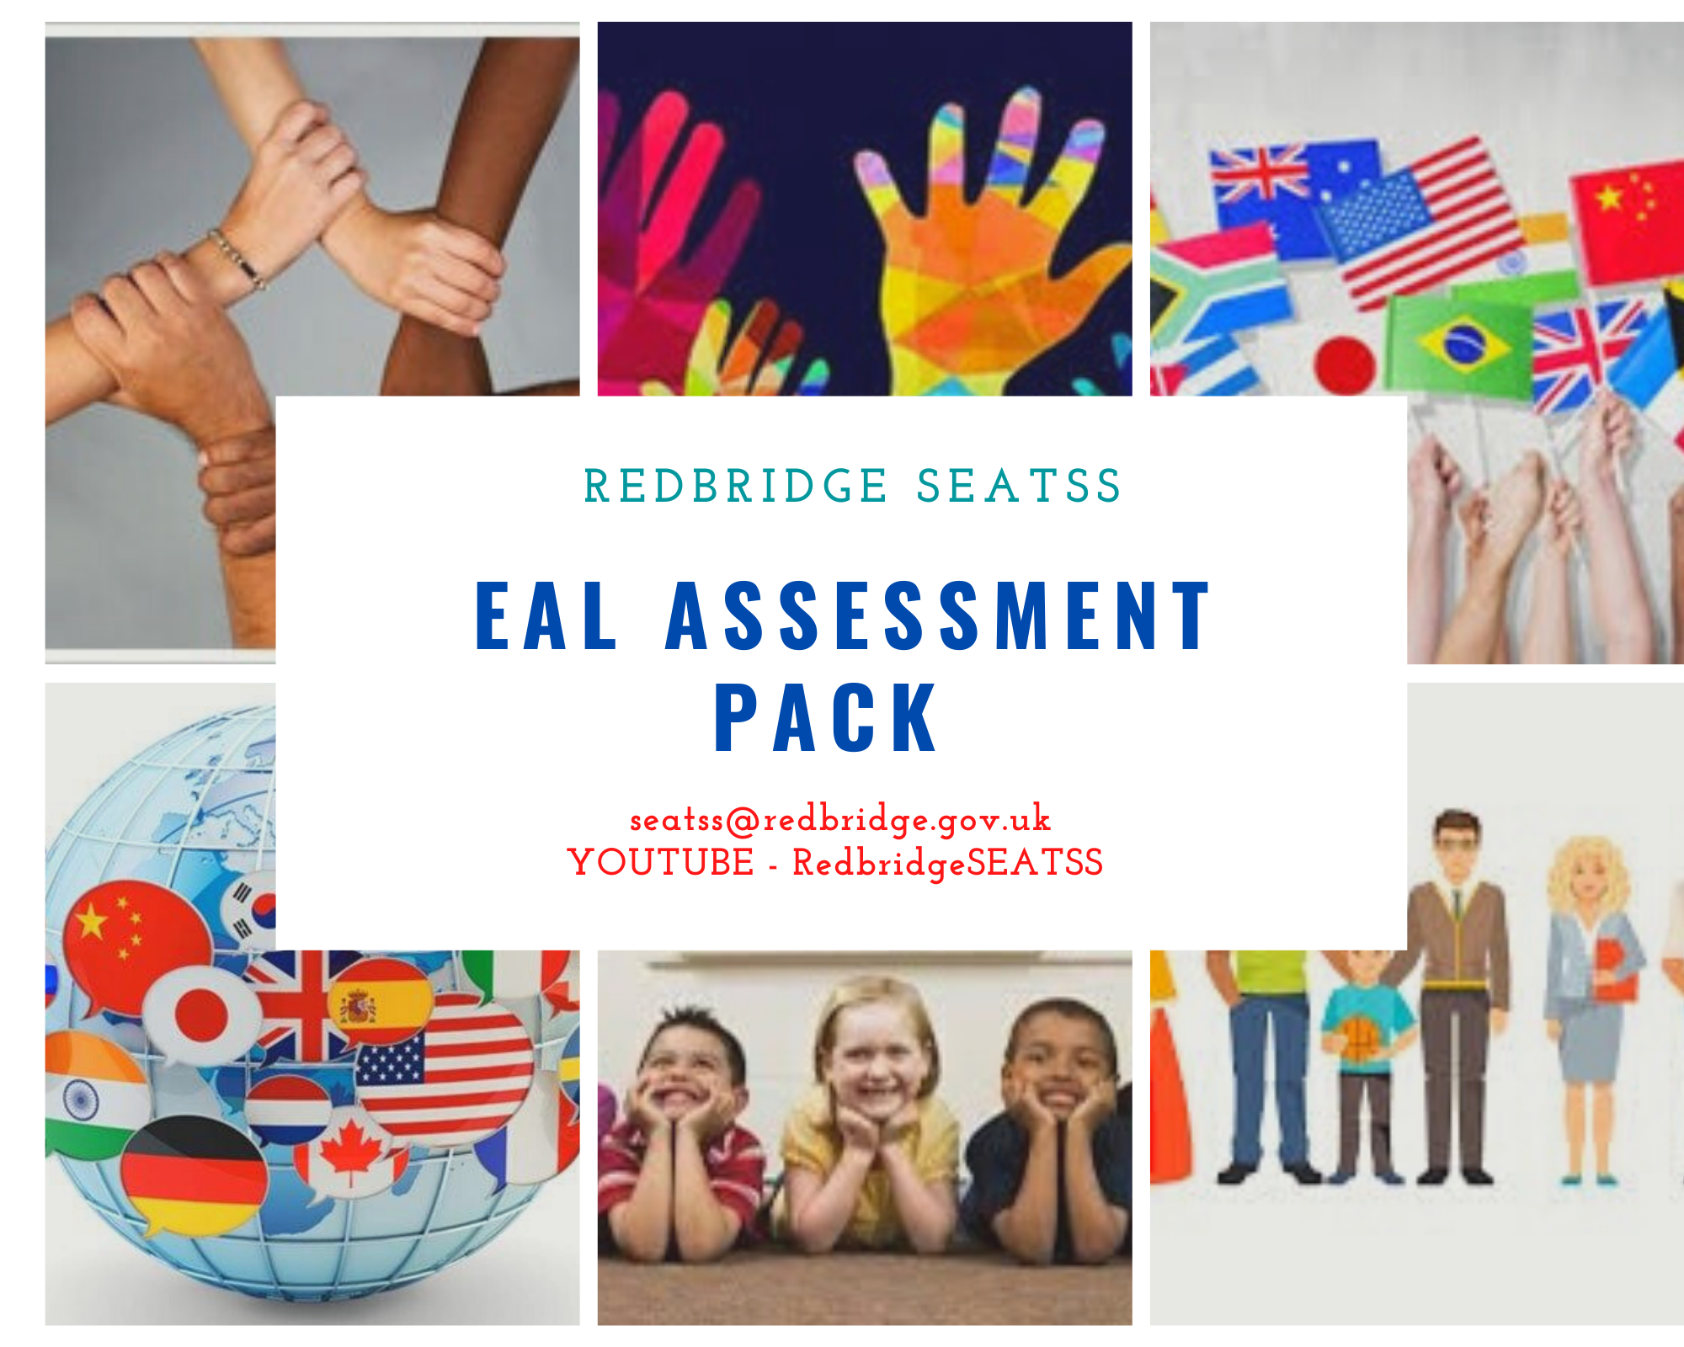This S.E.a.T.S.S EAL Assessment pack was designed as a simple tool for SENCO’s to use.
Very often EAL is intertwined with SEN and it is difficult to ascertain which factor is having the greater impact.
The aim of the pack is to assess how much English Language a student has, but also you can use the translate option in Word, in order to check their understanding in the student’s home language

Redbridge SEaTSS EAL Assessment
Before starting the assessment -click on dictate button on the toolbar.
- Open the EAL Assessment Word document.
- Turn on ‘Dictate’ option

Once selected you should see this image at the bottom of the page.

- Complete the Assessment in English
- Repeat using the student’s own language. To change the language, click on a settings cog next to microphone and you can select from a range of languages

All about you
- What is your name?

- How old are you?

- Where were you born?

- Who do you live with?

- Have you got any brothers and sisters?

- What do you like doing?

- What do you like at school?

- What do you dislike at school?

- Who are your friends?

- What do you like to eat/ drink?

Talk about a picture
Using this or any other picture – ask the following questions
- Where are the family?
- What are they doing?
- How many people are in the family?
- How many bags is the father carrying?
- What is the Mother wearing on her feet?
- How many parcels is the boy carrying?

Everyday Objects

How many can you name?

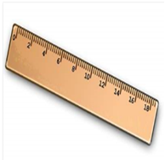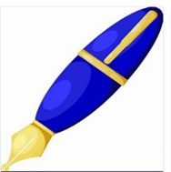
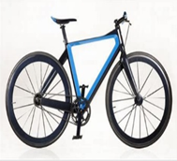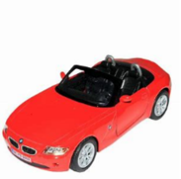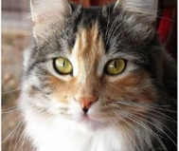

Colours

How many can you name?

Naming Colours
How many can you read?

red | blue | yellow
white | black | orange
pink | purple | brown
green | grey

Lower Case Letters (phoneme and name)

q | w | e | r | t | y | u
i | o | p | a | s | d | f
g | h | j | k | l | z | x
c | v | b | n | m

Upper Case Letters (phoneme and name)

Q | W | E | R | T | Y | U
I | O | P | A | S | D | F
G | H | J | K | L | Z | X
C | V | B | N | M

Numbers
How many can you name?

1 | 2 | 3 | 4 | 5
6 | 7 | 8 | 9 | 10
11 | 12 | 13 | 14 | 15
16 | 17 | 18 | 19 | 20

25 | 42 | 100 | 201 | 59
348 | 99 | 269 | 827 | 77

Can you write numbers in order 1-10?

How many?
Shapes

How many can you read?
the | that | not | look | put
and | with | then | don't | could
a | all | were | come | house
to | we | go | will | old
said | can | little | into | too
in | are | as | back | by
he | up | no | from | day
I | had | mum | children | made
of | my | one | him | time
it | her | them | Mr | I’m
was | what | do | get | if
you | there | me | just | help
they | out | down | now | Mrs
on | this | dad | came | called
she | have | big | oh | here
is | went | when | about | off

KS 1
Can you draw a picture of yourself and label your body parts?

KS2
Can you write about your favourite things to eat?

EAL Summary sheet
Student’s name
D.O.B
Ethnicity
Languages spoken at home

Languages written

Birth country
Countries lived
Schools attended prior to this school
Date arrived in the UK
Date starting current school
SEND assessed/ supported in previous schools

SEND reported

Additional information

Summary report
Initia Observations/ any
conversations initiated
All about me

Christmas picture q’s

Everyday objects

Colours

Numbers
1-10
10-20
1-100
Ordering 1-10
Shapes

HFW (out of 100)

