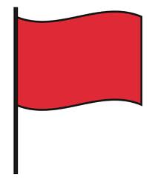

FINE MOTOR

Below are aspects of a child’s development that may be of concern, if these are observed it may well be worth considering a referral for an assessment by a health professional.

If a child is...
• Frequently in a fisted position with both hands after 6 months of age
• Not bringing both hands to midline (centre of body) by 10 months of age
• Not banging objects together by 10 months of age
• Not clapping their hands by 12 months of age
• Not deliberately and immediately releasing objects by 12 months of age
• Not able to tip and hold their bottle by themselves and keep it up, without lying down, by 12 months of age
• Still using a fisted grasp to hold a crayon at 18 months of age
• Not using a mature pincer grasp (thumb and index finger, pad to pad) by 18 months of age
• Not imitating a drawing of a vertical line by 24 months of age
• Not able to snip with scissors by 30 months
Here are some other fine motor "red flags":
• Using only one hand to complete tasks
• Not being able to move/open one hand/arm
• Drooling during small tasks that require intense concentration
• Displaying uncoordinated or jerky movements when doing activities
• Crayon strokes are either too heavy or too light to see
• Any know medical diagnosis can be considered a "red flag": Down's Syndrome, cerebral palsy etc.

This information has been prepared by Newbridge Outreach Service
You are welcome to share with others – please acknowledge where you obtained it from.

