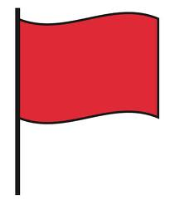

Gross Motor

Below are aspects of a child’s development that may be of concern, if these are observed it may well be worth considering a referral for an assessment by a health professional.
If a child is...
- Not rolling by 7 months of age
- Not pushing up on straight arms, lifting his head and shoulders, by 8 months of age
- Not sitting independently by 10 months of age
- Not crawling ("commando" crawling--moving across the floor on his belly) by 10 months of age
- Not creeping (on all fours, what is typically called "crawling") by 12 months of age
- Not sitting upright in a child-sized chair by 12 months of age
- Not pulling to stand by 12 months of age
- Not standing alone by 14 months of age
- Not walking by 18 months of age
- Not jumping by 30 months of age
- Not independent on stairs (up and down) by 30 months of age
Some additional gross motor "red flags":
- "walking" their hands up their bodies to achieve a standing position
- only walking on their toes, not the soles of their feet
- frequently falling/tripping, for no apparent reason
- unusual creeping patterns
- any known medical diagnosis can be considered a "red flag": Down's syndrome, cerebral palsy, congenital heart condition etc.
This information has been prepared by Newbridge Outreach Service
You are welcome to share with others – please acknowledge where you obtained it from.

