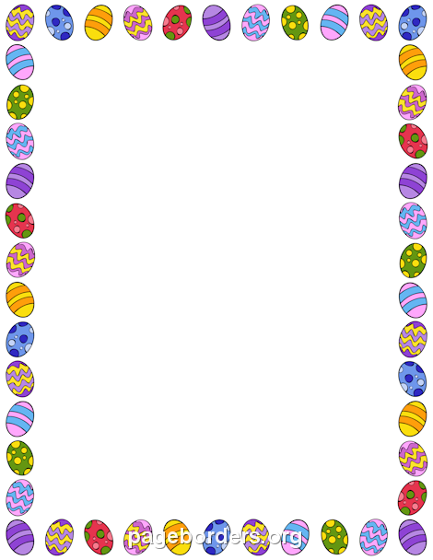

Easter Activities

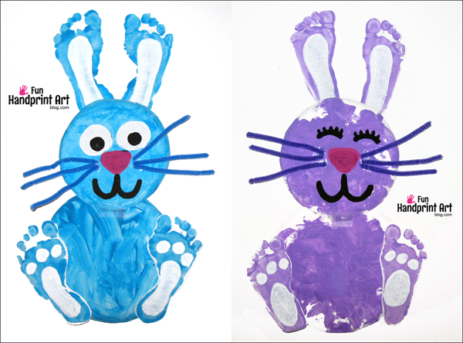
Footprint Bunny Picture
Paint each child’s feet and let
them make 2 sets of footprints
on paper, these will form the
ea ears and feet of the bunny.
Paint or potato print 2 circles
for the body and head and
add features!

Carrot Footprint Decorations
Paint your child’s feet orange and
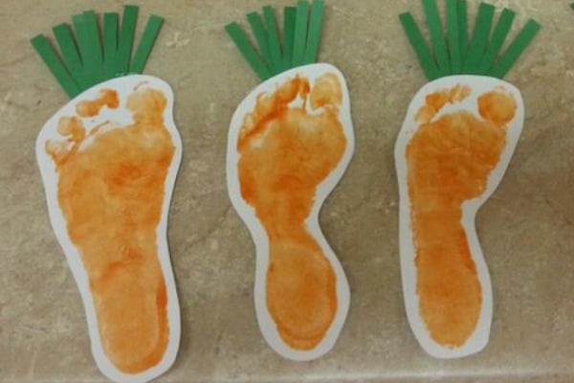
get them to print them on paper.
When dry cut them out and
let children cut some strips of
green paper which they can
stick to the top of the footprint.
Attach a loop of ribbon to the
top and write an Easter message
on the other side.

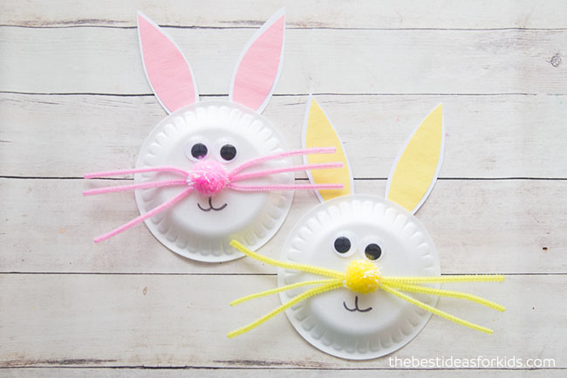
Easter Bunnies
Using paper plates create
a face for your Easter
bunny. Use pipe cleaners
or straws for whiskers, stick
on eyes and draw
features. Make ears from
card and attach.

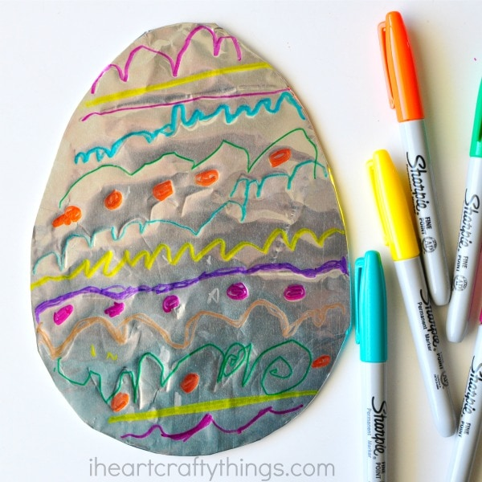
Easter Egg Decoration
Cut an egg shape out of card,
or draw the shape for your
child to cut out.
Cover it in aluminium foil.
Use pens to draw designs and
patterns on the egg.
Encourage them to be bold
and colourful!

