fine motor milestones
Bricks
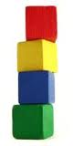
12-18 mths | 18mths- 2 yrs | 2 yrs
Can build a tower of 2 blocks high | Can build a tower of 3-4 blocks | Can stack a block tower 9 blocks high

Scissors
2 yrs old | Make snips on paper with scissors  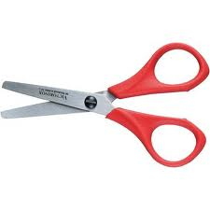
3 yrs old | Cuts a piece of paper in half  Cuts along a thick line with no more than 1 cm deviation from the line
4 yrs old | Can cut big circles with scissors  Can move the paper while cutting along a line
5 yrs old  6 yrs old | Cuts out a circle  Cuts well with scissors, no deviations from the cutting line

Drawing/ writing
12- 18 mths | Scribbles using a crayon
18 mths- 2 yrs | Begins to hold crayon with fingertip and thumb, not palmar grip  Scribbles using a pencil
3 yrs old | Can draw a circle after being shown  Copies prewriting lines of vertical, horizontal, and circle shapes
4 yrs old | Can copy cross shapes, / , \, square and X shapes  Can colour within a picture with no more than 1 cm deviations from the colouring lines
5 yrs old | Grasps a pencil correctly  Begins to print their name  Copies a triangle shape  Draw a diamond shape when given a model  Draws a person with at least 6 different body parts
6 yrs old | Can copy first name  Prints 3 or more simple words  Can print all numbers 0-9  Can print all letters of the alphabet, upper case and lower case

General fine motor activities

18 mths- 2yrs | Removing pegs from a pegboard  Can turn pages in a book one page at a time  Can open loosely wrapped packages or containers
2yrs | Manipulates clay or play dough Can turn doorknobs  Can pick up small objects with pincer grasp (index finger and thumb)  Can complete 3 piece puzzles  Can screw lids on containers on and off Can string large beads
3 yrs | Laces a card  Can unbutton large buttons  Will string 1/2 inch beads  Sorts objects
4 yrs | Uses dominate hand  Can touch the tip of each finger to their thumb  Completes puzzles of 4-5 pieces
5 yrs | Opens a lock with a key
6 yrs | Builds a small structure with blocks  Can put a 16-20 piece puzzle together
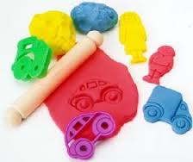
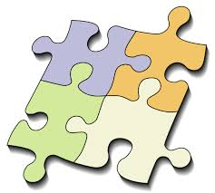
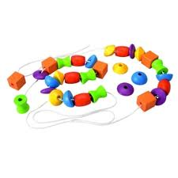

Self -care /dressing skills

2 yrs | Pulls off shoes  Removes socks  Pushes arms and legs through garments  Will wash hands independently  Zips and unzips large zippers  Can use a spoon correctly  Helps pull down pants  Finds armholes in pullover shirts  Removes unfastened jackets  Removes untied shoes  Removes pull-down elastic waist pants  Unbuttons large buttons  Puts on front button shirt
3yrs | Puts on socks and shoes (though it might be the wrong feet or socks upside down)  Puts on pullover shirts with some help  Buttons large buttons  Pulls down pants  Zips and unzips with help to place on track  Identifies front of clothing  Snaps fasteners  Unbuckles belt  Buttons 3-4 buttons at a time  Unzips jacket zipper
4 yrs | Can use a fork correctly  Can get dressed and undressed without help  Removes pull over shirts without help  Buckles belt  Zips jacket  Puts on socks correctly  Identifies front and back of clothing
5 yrs | Can tie their tie  Dresses alone  Ties and unties knots
6 yrs | Uses a knife to cut food  Ties bows and shoelaces

