Sand foam
You will need clean sand, shaving cream and a large tray or tub.
There is no real defined amounts for the ingredients, the sand and shaving cream amounts can be adjusted until you are happy with the consistency. We started off with 3 cups of sand and 200ml of shaving cream, however, we added another 3 cups of sand to our mixture to explore what would happen.

Instructions:
- Add 3 cups of sand to the tray.
- Gradually add the shaving cream and combine using hands. Add more shaving cream until desired consistency is made.
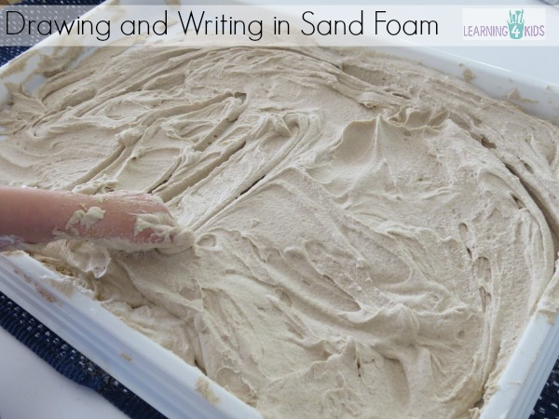Save

Learning Opportunities
- Creativity
- Fine Motor Development – Pre-writing skills
- Hand-Eye Coordination
- Sensory- Development of the sense of touch. Feeling and manipulating objects.
- Oral language development- using descriptive language.

Rubbery Gloop

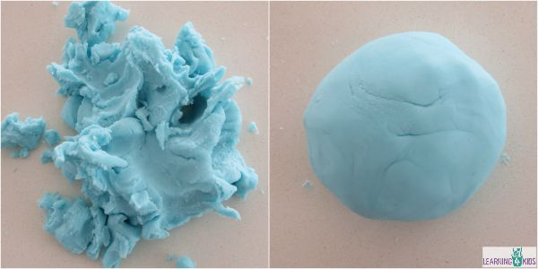Save
Rubbery Goop can be stretched and pulled apart into smaller pieces (not dry or crumbly) and it all rolls back up into a smooth soft ball.

2 cups bi-carbonate soda
1 ½ cups water
1 cup of cornflour (corn starch)
Food colouring (optional)

Instructions:
- Combined all ingredients into a saucepan.
- Mix the ingredients together using a whisk to remove lumps.
- Heat on stove stirring with a wooden spoon.
- Bring the mixture to the boil continuously stirring.
- Small lumps will begin to appear, continue to stir until a thick mixture has formed.
- Turn out onto the bench. Be careful the Rubbery Goop will be very hot!
- Knead together to form a smooth ball of Rubbery Goop.
- Store in a plastic zip-lock bag or air tight container.

There are no preservatives in this recipe and depending on how many children play with the Rubbery Goop, it can last up to two weeks.

Snow Dough:
2 cups corn flour (corn starch in US)
1/3 to 1/2 of a cup vegetable oil
3-4 tablespoons silver glitter
(You can also use baby oil, which makes it smell and feel even nicer, but do NOT use with under 3s or any child who may put it in their mouth as it is dangerous if ingested. )
This recipe does not create a huge amount of snow dough, just enough to cover the base of a washing up bowl by about 2 inches. If you want more for a larger scale sensory tub, then increase the quantities accordingly.
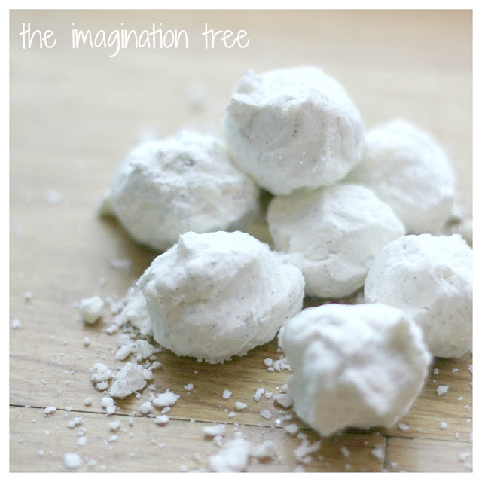

Soda dough:
Combine 1 cup flour, 2 cups baking soda, 1 cup water, and a few drops of food colouring in a sauce pan. Cook over medium heat. Stir until it looks like mashed potatoes. Remove from heat and place in a glass bowl. Cover with a cloth until cool.

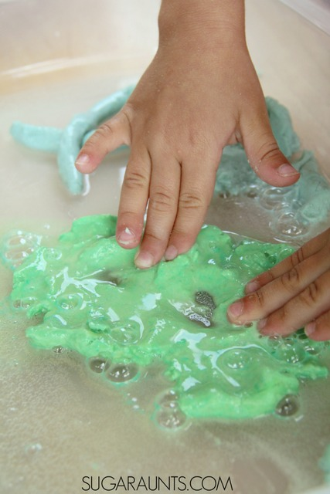

Next comes the fun part: Making the fizzy dough into FIZZY dough! Simply add vinegar for a bubbly reaction that is very fun to watch and play with. We put our dough into a bin and poured and painted vinegar all over the dough. It became a squishy sensory mess of a dough, but still squishy. Add more vinegar for a thinner substance. My kids loved squishing it between their fingers.

Edible Slime (Chemical and Borax Free!)

Basil seed,
Cornflour
Water
Food colouring (optional - we used Neon Green here)

Measure 1/4 cup of basil seeds into a bowl and add one full 16oz box of cornflour. Mix them together (kid hands are really good at this part). Add food colouring (if desired) to 2.5 cups of water. Add the water to your cornflour and seed mixture and stir well. I find that it's easiest to do this part with my hands. You will ultimately end up kneading the slime like bread dough as over the span of 5 minutes, the seeds will begin to absorb the water and it will begin to thicken the mixture. If you find any clumps of seeds while kneading, break them up with your fingers. Once the slime is completely uniform feeling - you're good to go!
Where do you find Basil Seeds:
The best place to find basil seeds is in an Asian or International Specialty Food Store:

