This document is the property of the Author – please do not reproduce without
This document is the property of the Author – please do not reproduce without acknowledging this and Newbridge Outreach Service.

GROSS MOTOR SCREENING AGE 6 yrs

Pupil’s name: DOB: Age:
School:
Other factors to consider:

Make sure they can complete activities on age3, 4 and 5 sheets before doing these activities.

Observable motor skills | Confident | Nearly there | Not achieved
Throw and catch a small ball well

Can skip

Can hold a position for 10 secs

Can walk along a balance beam

Can move into four point kneeling

Can bounce a tennis ball on floor once and catch with one hand

Can jump over a rope

Aeroplane for 15- 20 secs

Superman for 15- 20 secs

Other comments:

- Aeroplane – ask students to lift up their head, arms and feet off the floor

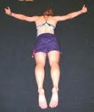

- Superman

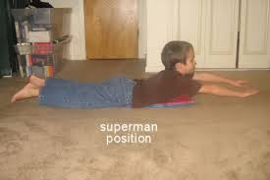

- Isolating body parts while in four point kneeling

