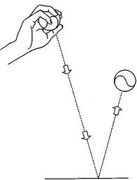

Can you bounce a ball and catch it?