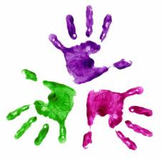



Healthy Hands

Marble Challenge

****

……………….

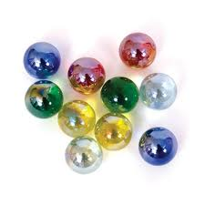

completed ‘The Marble Challenge’ in

………..secs