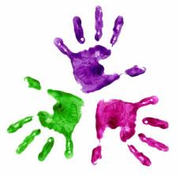
Healthy Hands
KS1 – Hand exercises

Sit down at the table; ensure you are sitting with your feet flat on the floor and bottom back in the chair.
- Put your hands flat on the table with your palms down.
- Can you turn your hands over (palms facing upwards)?
- Repeat hands, turning back and forth.
With palms down on the table, can you….
- make two fists
- make one fist and one flat hand then swap
- stretch fingers out in a fan shape
Using right hand only……..
- Can you touch your index finger and thumb?
- Can you touch your middle finger and thumb?
- Can you touch your ring finger and thumb?
- Can you touch your little finger and thumb?
Repeat with left hand.

