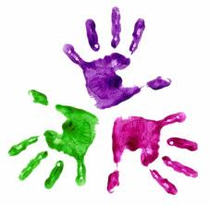
Healthy Hands
KS1 – Relaxation

- Make sure your feet are flat on the floor, your bottom is on the chair, and back is straight.
- Rotate shoulders – make circles and loosen shoulder muscles x 5
- Shrug your shoulders x 5
- Hang arms/ hands down by your sides and shake
- Place palms together- fingers spread, press together and release
- Push elbows out – lift up and down
- Fingers interlaced – stretch arms out in front.
- Push palms away from the body x 5
- Arms down by your sides- clench and unclench hands
- Shake hands
- Flick fingers- one at a time
- Rest hands in your lap, close your eyes, focus upon your breathing slowing down.
- While the students have their eyes closed, place a sticker and homework in front of them.
- End session

