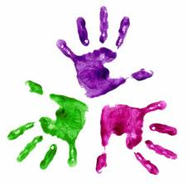
Healthy Hands
KS1 – Ribbons

Hand out a ribbon to each student and adult present.
Pupils to stand away from the table in a clear space.

Hold the ribbon in your right hand
Can you make a large circle over your head?
Can you make a large circle to your right side?
Can you make a large circle to your left side?

Hold the ribbon in your left hand
Can you make a large circle over your head?
Can you make a large circle to your right side?
Can you make a large circle to your left side?

Hold the ribbon and try to make large circles around your head ensuring you do not touch your head or shoulders.

Hold the ribbon with a straight arm out in front of you, slowly turn the ribbon to make a circle with your ribbon.

