

**Calming activities/relaxation (5mins)**

1. Relaxation routine – nine simple actions to encourage physical and mental relaxation.

**Writing activities**

1. Directional formation

**Pre- writing activities**

1. Rainbow writing – tracing over smooth curved lines ( position paper on the wall)
2. Writing letters inside different size boxes ( choose letters in students names)

**Fine motor exercises (Finger exercises)**

1. Dowelling sticks – hands on, lift fingers, straight arm lift, overhead , behind neck
2. Marble Challenge – timed exercise to place marbles into a small container using a different size spoons

**Bilateral co-ordination exercises Hand/ arm movement**

1. Ribbons- see ribbon sheet
2. Hand exercise routine

**Whole body- Postural Readiness Activities**

1. Welcome routine to ensure good sitting
2. Simon says – pointing to body parts with index finger
3. Simon says with eyes closed – can they find their body part accurately with eyes closed?

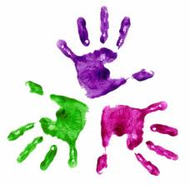

Healthy Hands

KS1 – Week 1

