**Pre- writing activities**

1. Drawing a face ( see sheet)
2. Spiral drawing ( see sheet)
3. Dots in boxes ( see sheet)

**Fine motor exercises (Finger exercises)**

1. Dowelling sticks – hands on, lift fingers, straight arm lift, overhead , behind neck
2. Foam tubes- who can join the longest chain by joining with water using finger tips

(Magic Maize can be purchased from ELC)

1. With pencil gently poke holes in foam to make ‘spots’.

**Bilateral co-ordination exercises Hand/ arm movement**

1. Ribbons - as week 1, + high and low large circles

* straight arms level with shoulders – circles clockwise /anticlockwise

1. Hand exercise routine – as last week
2. Cross hand exercises – see sheet



**Calming activities/relaxation (5mins)**

1. Relaxation routine – nine simple actions to encourage physical and mental relaxation.

**Writing activities**

1. B and d sheet

**Whole body- Postural Readiness Activities**

1. Welcome routine to ensure good sitting
2. Bean bags on head- who can sit still? , move their head from side to side, shrug one shoulder and then another without dropping the bean bag from their head.

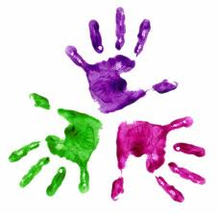

Healthy Hands

KS1 – Week 2

