**Pre- writing activities**

1. Drawing detail on face- attention to detail ( see sheet)
2. Rainbow shape enlarged to A3 shape or larger- pin to the wall and ask students to draw over arcs shapes with arms straight and strong.

**Fine motor exercises (Finger exercises)**

1. Dowelling sticks – hands on, lift fingers, straight arm lift, overhead , behind neck
2. Painting o and x around the edge of a plain sheet of paper.

**Bilateral co-ordination exercises Hand/ arm movement**

1. Ribbons
2. Hand exercise routine
3. Clapping patterns



**Calming activities/relaxation (5mins)**

1. Relaxation routine – nine simple actions to encourage physical and mental relaxation.

**Writing activities**

1. Put o and x in boxes ( decreasing sizes)

**Whole body- Postural Readiness Activities**

1. Welcome routine to ensure good sitting
2. Pointing to body parts with eyes closed
3. Sleeping statues

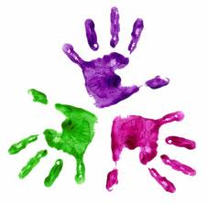

Healthy Hands

KS1 – Week 5

