**Pre- writing activities**

1. Using a pencil sharpener – sharpen pencils to make as many shavings as possible.
2. Stick shavings on top of paper bag to make hair

**Fine motor exercises (Finger exercises)**

1. Dowelling sticks – demonstrate what they can do
2. Marble Challenge – repeat this activity from Wk 1, give out certificates for quickest student. You can make certificates free from this site;

http://www.senteacher.org/Worksheet/3/FreeCertificates.xhtml

**Bilateral co-ordination exercises Hand/ arm movement**

1. Ribbons- each pupil to demonstrate what they can do?
2. Playdough- Give each student the same size piece of dough.

Who can roll the longest snake shape maintaining the dough in one piece?



**Calming activities/relaxation (5mins)**

1. Relaxation routine – nine simple actions to encourage physical and mental relaxation.

**Writing activities**

1. Draw face on paper bag – prompting extra details
2. Writing name on Healthy Hands Certificates

**Whole body- Postural Readiness Activities**

1. Welcome routine to ensure good sitting
2. Sit with hands on head and then arms out straight. Who can hold this pose the longest?

Stickers given to the winners.

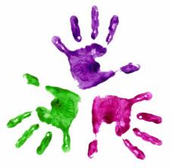

Healthy Hands

KS1 – Week 6

