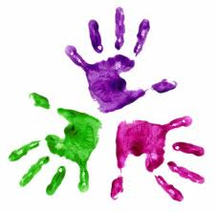
Healthy Hands
KS1 –Welcome routine

‘Hello everyone’ (give out name stickers and take register)
‘Is everyone sitting well?’
‘Is your bottom back in your seat?’
‘Is your back touching the back of your seat?’
‘Are your feet flat on the floor?’
‘Can you put your hands flat on the table?’
‘Take a big breath in and out’
‘Clap your hands together’ (lots of claps)
‘Let’s get started………..’

