Healthy Hands
KS1 –Cross hand exercises

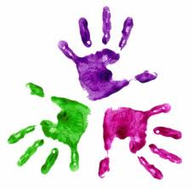

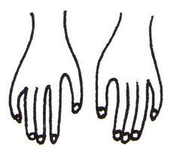

- Mark the back of each hand using a felt tip pen.
- Position counters on table top as in picture.
- Ask pupils to place hands on the table top with thumbs touching.
- Then call out either ‘blue’ or ‘red’, and the students are expected to reach across their body to pick up the counters as quickly as they can.

Hand out a ribbon to each student and adult present.
Pupils to stand away from the table in a clear space.

