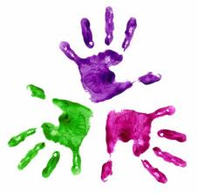
Healthy Hands
KS1 –Drawing a face

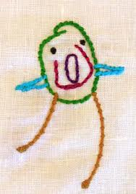

Give each student a blank sheet of paper.
Ask students to copy you.
Draw step by step;
- Large circle
- Two eyes
- Nose
- Mouth
- Ears
- Eyebrows
- Hair

