

**Calming activities/relaxation (5mins)**

1. Relaxation routine – nine simple actions to encourage physical and mental relaxation.

**Writing activities (10mins)**

1. X1X1X1X1 timed activity
2. x1-x1-x1-x1- timed activity

**Hidden writing activities (15 mins)**

1. Copying abstract graphics – use sports logo’s
2. Wallpaper activities ----------------🡪

**Fine motor exercises (Finger exercises) (10 mins)**

1. Dowelling / plastic tube activity
2. Marble challenge – different size spoons
3. Red / blue colour command- see Cross Hand activity

**Bilateral co-ordination exercises Hand/ arm movements (10 mins)**

1. Ribbons /ropes/ chains
2. Hand exercise routine

**Whole body- Postural Readiness Activities (10 Minutes)**

1. Point to parts of the body
2. Stand still – eyes open / eyes closed, point to body parts with eyes closed
3. Put the football in the goal activity

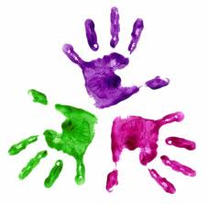

Healthy Hands

KS3 – Week 1

