

**Calming activities/relaxation (5mins)**

1. Relaxation routine – nine simple actions to encourage physical and mental relaxation.

**Writing activities (10mins)**

1. P and B formation
2. P and B on peers backs
3. Maze – selection from [www.eduhelper.com](http://www.eduhelper.com)

**Hidden writing activities (15 mins)**

1. Carbon paper sandwich
2. X1X1X1X1X1X1X1X1 and extra patterns

**Fine motor exercises (Finger exercises) (10 mins)**

1. Dowelling / tubes
2. Hand exercises
3. Picking up pennies – right hand, left hand then alternate.

**Bilateral co-ordination exercises Hand/ arm movements (10 mins)**

1. Ribbons/ chains /ropes
2. Tracing over perfect circular shape on wall, one arm then the other

**Whole body- Postural Readiness Activities (10 Minutes)**

1. Standing on one leg then the other- which is the strongest leg?
2. On one leg bend over and pick object out of bucket
3. Hopping race

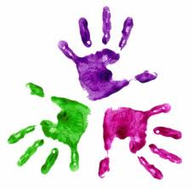

Healthy Hands

KS3 – Week 3

