

**Calming activities/relaxation (5mins)**

1. Relaxation routine – nine simple actions to encourage physical and mental relaxation.

**Writing activities (10mins)**

1. Battleships

**Hidden writing activities (15 mins)**

1. Signature on cheques / signature X 10 same
2. Spirals both ways
3. Signature on paper on wall

**Fine motor exercises (Finger exercises) (10 mins)**

1. Dowelling / tubes
2. Hand exercises
3. Turning over pennies /counters / 100 dot square

**Bilateral co-ordination exercises Hand/ arm movements (10 mins)**

1. Ribbons/ chains /ropes
2. Hand exercises
3. Drumming – tapping / cross over

**Whole body- Postural Readiness Activities (10 Minutes)**

1. Holding crab shape
2. Leaning off seat – to reach bean bags either side ( 6)

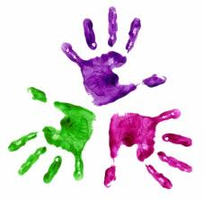

Healthy Hands

KS3 – Week 5

