**Fine motor exercises (Finger exercises) (10 mins)**

1. Dowelling / tubes
2. Hand exercises
3. Malteser challenge- place a large bag full of Maltesers into the bowl in the middle of the table, give each pupil a spoon and ask them to spoon one at a time in a race – these can be weaten at the end of the sessions.

**Hidden writing activities (15 mins)**

1. Pencil sharpener – amount of shavings pupil can form in 1 minute

- length of continuous shaving competition

2. Spilkins/ Pick up sticks



**Calming activities/relaxation (5mins)**

1. Relaxation routine – nine simple actions to encourage physical and mental relaxation.

**Writing activities (10mins)**

1. Fill out a form- bank account- use real documents from Banks/ Post Office
2. Name on certificate- print these from [www.senteacher.org](http://www.senteacher.org)
3. Wall of comments – write on a brick and stick on wall ( can use Post it Notes)

**Bilateral co-ordination exercises Hand/ arm movements (10 mins)**

1. Ribbons/ chains /ropes
2. Twister game

**Whole body- Postural Readiness Activities (10 Minutes)**

1. Hold body shapes
2. Press up’s

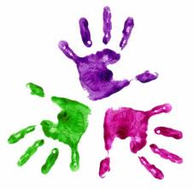

Healthy Hands

KS3 – Week 6

