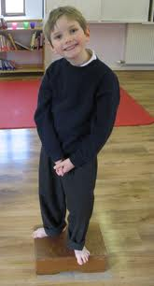

What is Hemiplegia (Hemiparesis)?
‘Hemi’ refers to a condition that affects one side of the body (Greek ‘hemi’=half).
The terms ‘right or left Hemiplegia’ is normally used depending upon on the side
affected.
It is caused by damage to some part of the brain during or soon after birth- this is known known as congenital Hemiplegia.
Hemiplegia
If in later life the brain receives an injury it is known as acquired Hemiplegia.
An injury to the left side of the brain will cause right Hemiplegia and visa versa.
Childhood Hemiplegia is relatively common affecting one child in 1,000.
80% of cases are congenital and 20 % are acquired.
How does it occur?
The causes are mostly unknown; however premature babies are at greater risk.
How to help?
Hemiplegia cannot be cured, but a lot can be done to minimise the effects. A
developing brain is flexible and other parts of the brain can be taught to
compensate.
Associated difficulties
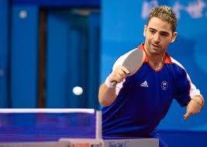
@50% of children with Hemiplegia also have other difficulties eg epilepsy, visual impairment, speech difficulties, perceptual, emotional or behavioural difficulties.
Information sheets
We provide a summary page with up to date information, videos’ links to resources, factsheets to give to staff/ families
http://redbridgeserc.org/conditions/category/cerebral-palsy-hemiplegia
UK Charities and support groups
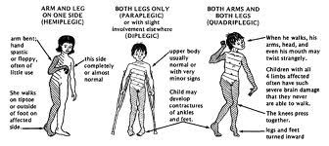
HemiHelp is a great resource for school staff and
parents. They have over 30 leaflets free to
download, parent support, school pack etc.
www.hemihelp.org.uk Tel: 08451232372
HemiHelp provides;
- Website and message board www.hemihelp.org.uk
- Helpline 08451232372
- Fun days with regional ‘try it’ activity days.
- Conferences, local groups, etc
- PEN PALS scheme ( for children 5 +yrs)
- Primary Schools Pack
Hemihelp free factsheets
http://www.hemihelp.org.uk/hemiplegia/publications/leaflets/
- What is Hemiplegia?
- HemiHelp Services
- Family and Friends ( highly recommended to give to teachers as has simple top tips)
- Brothers and sisters
- Early Years Education and advice
- Schools Pack – highly recommended
- Epilepsy and Hemiplegia
- Visual Perceptual Difficulties – recommended reading as this is often overlooked
- Emotional and behavioural difficulties
- Coping with Behaviour Problems
- Equipment list
- Dressing /Shoes/ Shoe lacing
- ICT/ Accessing computers
- DLA ( good guidelines to completing the form), grants and benefits
- Sports and keeping active
- Over 16’s page
- Advice with regards to riding bikes, music etc
Specific advice for schools
Early Years
http://www.hemihelp.org.uk/professionals/education/pre_school/
Primary School
http://www.hemihelp.org.uk/hemiplegia/publications/new_schools_pack
Secondary School
http://www.hemihelp.org.uk/professionals/education/secondary/

Equipment
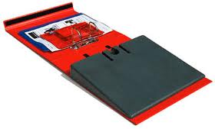 | Posture Pack | http://www.backinaction.co.uk/posturepack
 | Writing slope | http://www.thedyslexiashop.co.uk/writing-slope-1.html  or Amazon
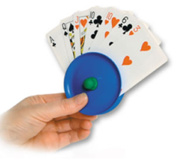 | Card holder | http://www.thedyslexiashop.co.uk/circular-card-holder.html
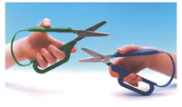 | Easy grip scissors | http://www.thedyslexiashop.co.uk/easi-gripr-scissors-right-handed.html  also available in left handed
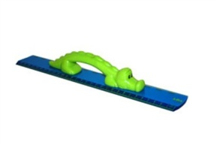 | My first ruler | http://www.thedyslexiashop.co.uk/my-first-ruler.html
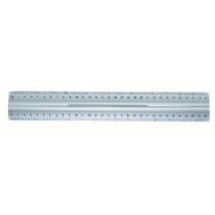 | Ruler with handle | http://www.amazon.co.uk/Wedo-0525235-Aluminium-Slip-Proof-Attachments/dp/B001OUZ6RC/ref=sr_1_18?ie=UTF8&qid=1348253352&sr=8-18
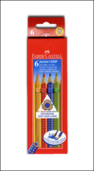 | Grip pencils- coloured and HB | http://www.thedyslexiashop.co.uk/faber-castell-jumbo-grip-colour-pencils-box-of-6-colours.html
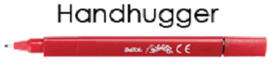 | Hand hugger pens & pencils | http://www.thedyslexiashop.co.uk/berol-handhugger-writing-pen.html
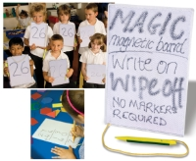 | Magnetic board | http://www.countyboroughsupplies.org/Products/Curriculum-Resources-And-Role-Play-Furniture/Learning-Boards-Laptop-Boards-And-Easels/Magnetic-Dry-Wipe-Laptop-Boards-And-Accessories/Magic-Write-OnWipe-Off-Magnetic-Boards.aspx
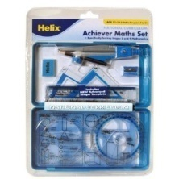 | Helix  Achiever | http://www.amazon.co.uk/gp/product/B0012E1YKI/ref=oh_details_o03_s00_i00
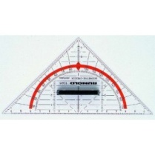 | Protractor with handle | http://www.amazon.co.uk/gp/product/B003XV94H8/ref=oh_details_o00_s00_i00
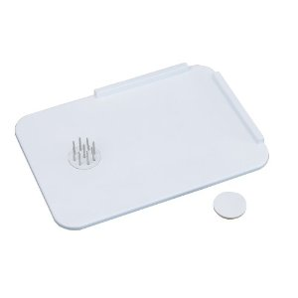 | Spreading  board | http://www.amazon.co.uk/gp/product/B003WUS3UE/ref=oh_details_o04_s00_i00
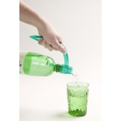 | Drinks pourer | http://www.amazon.co.uk/gp/product/B0065GI18Q/ref=oh_details_o02_s00_i00
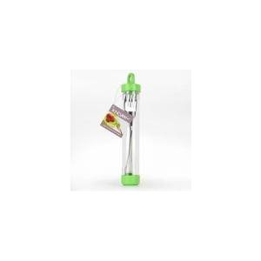 | Knork | http://www.amazon.co.uk/gp/product/B000P1OXMA/ref=oh_details_o02_s00_i00
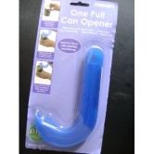 | Ring pull | http://www.amazon.co.uk/gp/product/B007SW2UPQ/ref=oh_details_o05_s00_i00
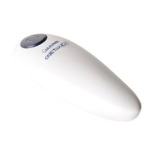 | One handed can opener | http://www.amazon.co.uk/gp/product/B000SCMG8O/ref=oh_details_o05_s00_i00
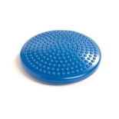 | Wobble cushion | http://www.amazon.co.uk/gp/product/B0057EQILE/ref=oh_details_o01_s00_i00
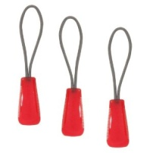 | Zipper pull | http://www.amazon.co.uk/gp/product/B0054IHL8M/ref=oh_details_o04_s02_i00
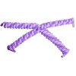 | Vizi  Coil  laces | http://www.amazon.co.uk/gp/product/B003UB1ZIM/ref=oh_details_o04_s00_i01
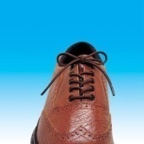 | Elastic  shoe laces | http://www.amazon.co.uk/gp/product/B002GTX79Y/ref=oh_details_o06_s00_i00
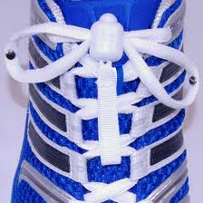 | Greeper  laces | http://www.greeper.com/index.php
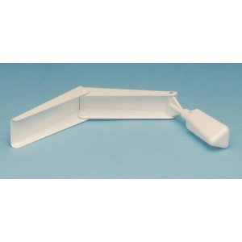 | Personal  Hygiene device | http://www.amazon.co.uk/gp/product/B008D6P2TW/ref=oh_details_o00_s00_i00
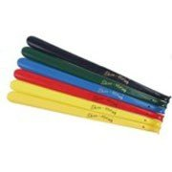 | Shoe  horn | http://www.amazon.co.uk/gp/product/B003WFRFBC/ref=oh_details_o06_s00_i00
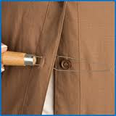 | Button Helper | http://www.boots.com/en/Age-UK-Button-Helper_1218560/
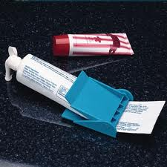 | Easy out tube squeezer | http://www.boots.com/en/Easy-Out-Tube-Squeezer_1240011/
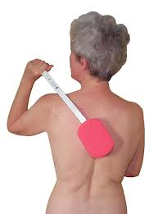 | Long  handled  sponge | http://www.livingmadeeasy.org.uk/personal%20care/long-handled-washing-aids-p/long-handle-sponge-0020696-588-information.htm
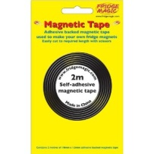 | Magnetic  tape | http://www.amazon.co.uk/gp/product/B001DT262C/ref=oh_details_o01_s00_i00
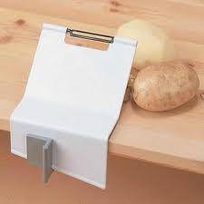 | One handed peeler | http://www.boots.com/en/Gordon-Peeler-and-Clamp_1236683/
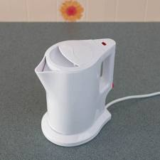 | Mini jug kettle | http://www.boots.com/en/President-Mini-Jug-Kettle_1217654/
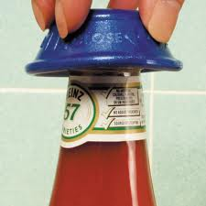 | Dycem bottle  opener | http://www.boots.com/en/Homecraft-Dycem-Bottle-Opener-Blue_983690/
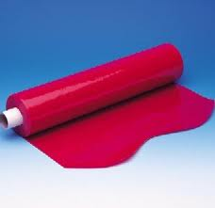 | Dycem  Non-slip  mat | www.redbridgeserc.org  We sell Dycem at cost- contact us 020285038773
 | Round  Scoop  dish | http://www.boots.com/en/Round-Scoop-Dish-Ivory_1232160/

Visual Perception
Visual perception involves;
- organisation of incoming information
- relates that information the things the brain has already experienced
What difficulties are linked to Hemiplegia?
- Attention Your brain makes cognitive maps constantly to decide what visual information to keep or discard otherwise we would overload our brains. Pupils with Hemiplegia have difficulty deciding what to keep and what to discard, sometimes they attend to the minute peripheral details and miss the main points.
- Visual fields difficulties A visual field defect can mean a pupil cannot see what happens on one or both sides of them.
- Hemianopia – loss of half the visual field, this affects the ability to scan letters/ words
- Visual neglect causes pupils to neglect what happens on the affected side, often causing them to be unsteady in new environments
- Visual perception-the visual image is seen but not fully interpreted in its spatial context causing difficulties with practical tasks, dressing and undressing, numeracy tasks especially charts and graphs and general organisational abilities.
- Disorganisation – most students with Hemiplegia have this profile and strategies and routines need to be actively taught to save time / energy later.
- Fatigue – the physical and mental compensation is extremely tiring for most pupils. Some pupils need to start from scratch every single time they encounter the same problem. Pupils with Hemiplegia need to constantly think about what they are doing and how they are going to do it.
- Self esteem – pupils can avoid tasks they perceive as too difficult and this can be perceived as a behavioural difficulty. Tasks need to be broken into small steps/ physically modelled.
Practical classroom strategies
- Pupil to sit square on to the board or face to face, avoid having to turn towards stimuli
- Computer screens should be at eye height
- LSA should sit alongside pupil to ensure the same eye line of vision
- Display boards/ whiteboards should be in direct line of vision to avoid distraction
- In group work the pupil should be seated in front or middle of the group
- Provide space around the pupil as they may lean
- Do not sit a left hander next to a right hander
- Place papers on a clip board so pupils can angle the paper easily
- Use blu tak or dycem if the papers slip
- New motor patterns are better learnt on a vertical surface
- Handouts should be visually clear and of good quality – grainy copy or lots of detail will lead the pupil to become distracted
- Be away from main door / busy area
- A4 is easy to mage than A5
- Use of ICT – prediction text/ word banks etc
- Writing frames/ mind maps
- Loose leaf pages are easier than exercise books
- Add magnetic strips on tools such as protractors
- Pre- prepare graphs, charts, diagrams to label

Specific maths problems
Pupils with spatial difficulties often cannot plot corners to make a square, find spacing /drawing lines, enter details on a graph etc difficult.
Difficulties with hundreds, tens and units, carry numbers and column addition generally.
Use graph /squared paper, highlighter pens to track columns
Use sticky labels when entering detail in tally charts.
When comparing bar charts/ lining up objects – use a line drawn on acetate
Use stencils as it gives a clearer outline
Getting around school
Aspects to consider;
- Opening doors
- Climbing stairs
- Carrying a heavy schoolbag
- Carrying sports equipment
- Carrying lunch tray
- Organisation
- Finding their way around school
Music
- One handed recorder – you can load one from Hemihelp or REACH or purchase one from www.dolmetsch.com .
- Piano/ Keyboard – Sound Sense has a range of music for one handed players.
- Cornet, Trumpet, French horn, Trombone, Euphonium and Flute are best suited to players who have Hemiplegia.
- Violin, Viola and Guitar – can be played, the weaker hand can be used to bow.
REACH- www.reach.org.uk is the Association for Children who have a hand or arm deficiency.
REMAP- www.remap.org.uk is a free bespoke service which adapts exisiting equipment for people with disabilities.
THE PIANO EDUCATION PAGE www.pianoeducation.org/pnoonhnd.html has a list of pieces for one hand.

CYCLING
Redbridge has its own dedicated cycling centre based in Hainault.
http://www.redbridgecyclingcentre.co.uk/
They have a range of adapted bikes and trikes you can try; they will also advice with regards to safety and providing a challenge.
If you have any further queries check our Hemiplegia page on our website www.redbridgeserc.org or contact us at Newbridge 0208 503 8773.

