Study Skills- Homework
- Write your homework in your planner or ask a member of staff to write it down for you as
you probably won’t remember when you get home.

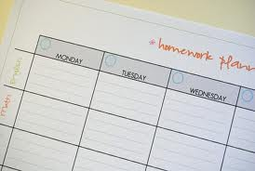

- Have a study buddy- have each other’s phone numbers so if you are unsure you can ring each
other when you are doing your homework.

- If you need a text book for homework make sure you add this detail in your planner.

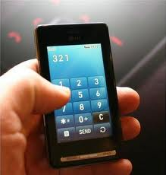
- Pace yourself – have breaks, snacks and try to involve some movement between tasks.
- Eating and drinking before you start will ensure you are ready to focus.
- Ensure you have space and light to study.

- Some people study easier if there is background music/ some people prefer total silence- ensure
you know which is easier for you.

- Organise yourself before you start- have a study checklist in your area to study to help you
collect all the items you need before you start.

Pens | Drink | Ruler  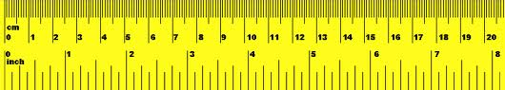
Calculator | Dictionary | Homework planner  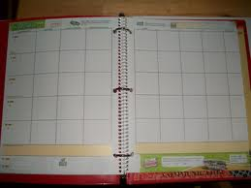
Spare paper | Text book  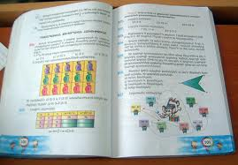 | Exercise book  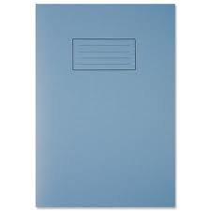
Worksheet  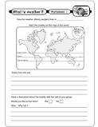 | Highlighters  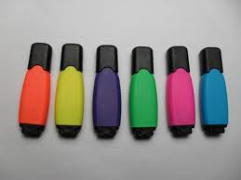 | Study cards/ Post it notes  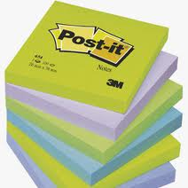

- Make a weekly homework timetable – each day when you get home write on the calendar what
day the homework needs to be done by.
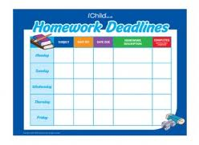

- Do the hardest homework first- don’t leave the hardest till late at night when you are tired.

- Longer essays/ pieces of coursework could be worked upon over several days – so plan and tick
off as you go as it will make the task seem more achievable once you get started

- Read instructions carefully- use a highlighter to highlight any actions you need to do. Ask an
adult to check you have understood the question correctly.

- If it seems overwhelming, take a ten minute break, have a shower, make a snack, but don’t watch
TV, start a game as it will be difficult to stop.

- Double check/ proof read- even ask others to read it out loud to you so you can hear the fluency
of your work.

- Put worksheets/ hand outs into clear plastic wallets.

- Use different coloured boxes/ folders for different subjects.

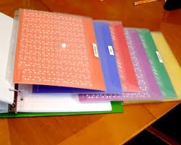

- Pack your school bag the night before- cross off books and homework as they are packed.

- Make day to day checklist- position on back of bedroom door – ensure that PE kit, money etc is
listed on the days you need to take it to school.

