I can Manage my Anger!

Learn all about how your brain works and how to manage your anger.
Watch the video https://www.youtube.com/watch?v=3bKuoH8CkFc
Then complete the worksheet.

How to complete the worksheet

Calm and Control – Write down as many things that keep you calm and in control for eg. Reading, swimming, eating a healthy snack, etc.

What Bugs Me – Write down all the things that bug you for eg. being teased, people entering my personal space, when an activity is too difficult, when I cannot solve a problem, etc.

Signals of Stress – How do you know when you are getting stressed? For eg. my face gets red, I make a fist, my heart starts to race, I feel hot, etc.

Next:
Take a Short Cut

You can take a short cut by noticing your signals of stress and immediately start doing the strategies and techniques to help you calm your anger. This way you avoid ‘flipping your lid’ and you get back on track.

Choose from the following list ways in which you will take a short cut and calm yourself down. If you already have your own calming down technique then you can write that down too.

Calming Down Techniques and Strategies

- Take 3 deep breaths or more if you need it.
- Do some stretches or exercise from www.cosmickids.com
- Drink some cold water, slowly.
- Count backwards from 10 or 20, slowly and take a deep breath after you reach zero.
- Walk away from whatever is making you angry.
- Talk it out by saying I feel angry because….
- Talk to an adult and ask for help.
- Wait and cool off.
- Go to a different activity. Get your mind on something else by watching something funny, doing some drawing/painting/arts and crafts/making something etc.
- Play with a squishy toy.
- Have a cuddle with your favourite teddy.
- Tell yourself I am managing my anger and the breath.

Next:

Complete the worksheet on the next page.

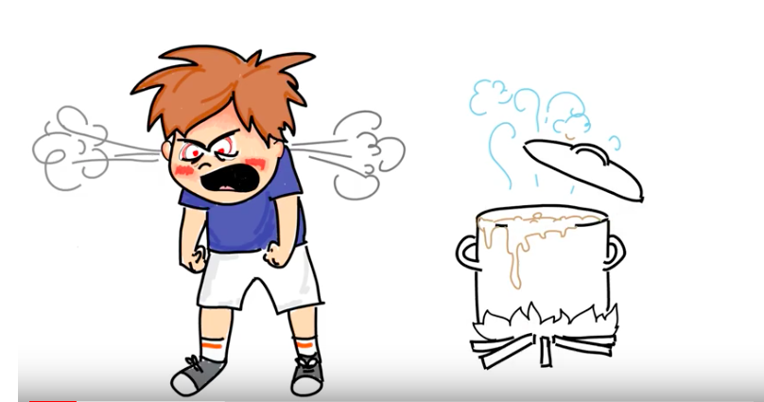
I can manage my anger!

Avoid flipping my lid.

Back on track

Take a Short Cut
Calm in  Control | What bugs  Me? | Signals of  Stress

