**Sit down at the table and make sure that you are sitting with your feet and bottom back.**

* **Put your hands flat on the table with palms down.**
* **Can you turn your hands over (palms facing upwards)?**
* **Repeat hands turning back and forth.**

**With palms down on the table, can you ……..**

* **Make two fists**
* **Make one fist and one flat hand then swap.**
* **Stretch fingers out in a fan shape.**

**Using right hand only…..**

* **Can you touch index finger to your thumb?**
* **Can you touch your middle finger to your thumb?**
* **Can you touch your ring finger to your thumb?**
* **Can you touch your little finger to your thumb?**

**Repeat with left hand.**

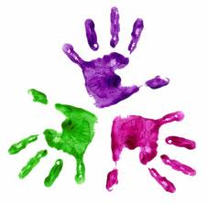



**Hand Exercises**

KS 3 Healthy Hands

**Healthy Hands – Newbridge Outreach Service**

**We are happy for you to copy but please acknowledge where you obtained the information from.**