**Hand out a ribbon/chain/ropes to each child and adult present.**

**Pupils to stand away from the table.**

**Hold the ribbon in your right hand……..**

* **Can you make a large circle over your head?**
* **Can you make a large circle to your right side?**
* **Can you make a large circle to your left side?**

**Hold the ribbon in your left hand………..**

* **Can you make a large circle over your head?**
* **Can you make a large circle to your right side?**
* **Can you make a large circle to your left side?**

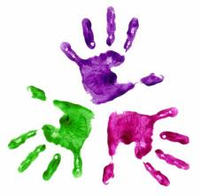



**Ribbons/ Chains**

KS 3 Healthy Hands

**Healthy Hands – Newbridge Outreach Service**

**We are happy for you to copy but please acknowledge where you obtained the information from.**