

**Bean bag challenge**

Ask the pupil to sit on a chair while lifting up their feet off the floor.

Place bean bags either side of them on the floor. Ask pupils to lean over and pick up the bean bag and throw into a bucket. Encourage the pupil to lean without holding onto the chair side.

**Tubes**

Using craft foam tubes- ask pupils to gently wet the end of the craft tubes and stick together eventually forming a unbroken circle.

**Pegs on plate**

Give each pupil a paper plate and 20 + pegs- ask them to place evenly around the paper plate by squeezing to open the pegs and placing along the plate edge. To make the task more challenging you can purchase very tiny pegs from craft shops- these require more strength to open them.

**Spirals**

Enlarge the worksheet to A3 sheet. Stick the paper on the wall. Ask pupils to complete the task while standing vertically.

**B/d sheet**

Dictate randomly b or d, ask pupils to record very quickly.

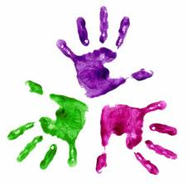



**KS3 week 2 - Activities**

Healthy Hands