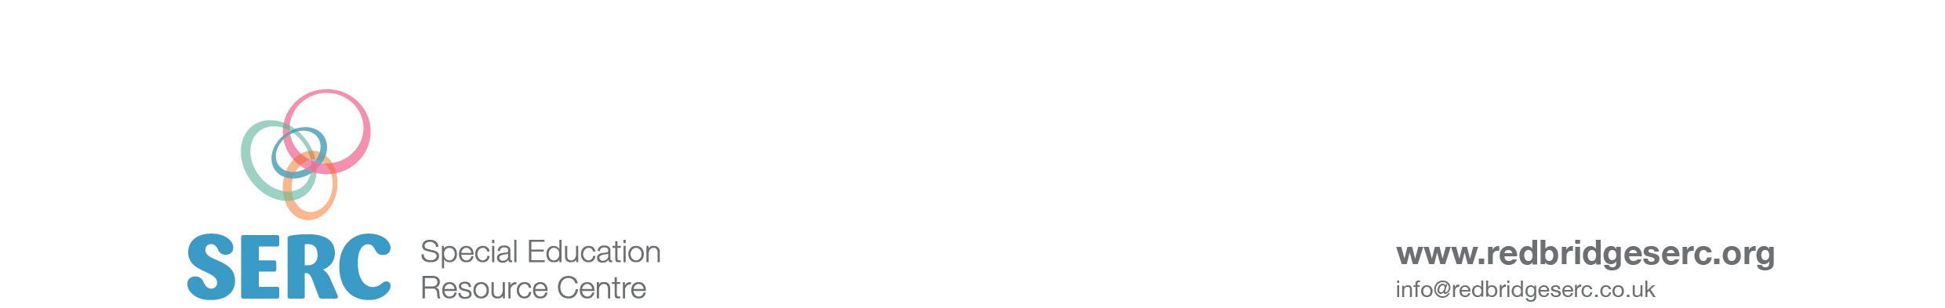

**Keep up balloon**

Students are each given a balloon. Time each student to see how long they can keep the balloon off of the floor without using their hands. Encourage them to stretch and reach to ‘head’, kick, knee the balloon to prevent it from touching the floor.

**Rice and sieve activity**Measure both the bubble pac and rice to ensure the students all have exactly the same. Choose a sieve with very fine holes, students can shake/ twist and turn the seive to help the rice go through or physically push rice through using their hands.

**Logo**

Give each student a logo and ask them to copy it. When finished give students a small piece of blu tac and ask them to ‘pin’ them on the wall. Ask an independent member of staff.

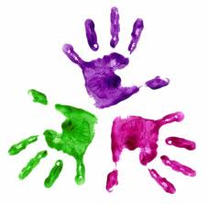



**KS3 week 4 - Activities**

Healthy Hands