Language activities

Vocabulary: Social words,
hello, bye bye, 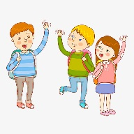

Game suggestions:

Telephone; talk into the receiver and say “hello” and “bye bye”. 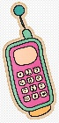

Puppets; talk to the puppets in imaginary play and make them wave “hello” and “bye bye”.

Draw a face on the palm of your hand to create a puppet 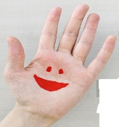

Peepo games; Mirror games;

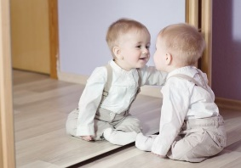

Look in the mirror and make funny faces. Say “hello” and “bye bye” to your faces.

Jack-in-the-box

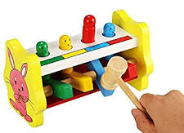

say “hello” as it pops up and “bye bye” as it goes down.

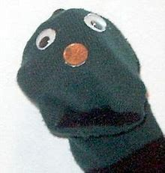
Make a simple sock puppet draw and cut out eyes, nose and mouth and stick or attach with Sellotape

“More”, “again”

Play-dough, food and drinks; give a little bit at a time to encourage your child to ask for “more”.

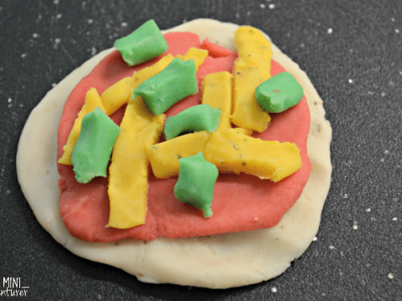

Easy playdough recipe
large mixing bowl
1 cup water
4 cups flour
2 to 4 tablespoons cooking oil
1 1/2 cups salt
Food colouring optional
Glitter optional
1.Put the flour and salt into the bowl.
2.Mix the oil, water and food colouring (if using)
3.gradually pour the liquid into the flour mix. Stir with wooden spoon or
hands.
4. knead into a smooth ball

Bubbles; wait for your child to look and attempt “more” before blowing more. Make own mix using 1 part washing up liquid to 4 parts water.

Bubble wands: most items with a hole can be used or make a circle with thumb and index finger and dip

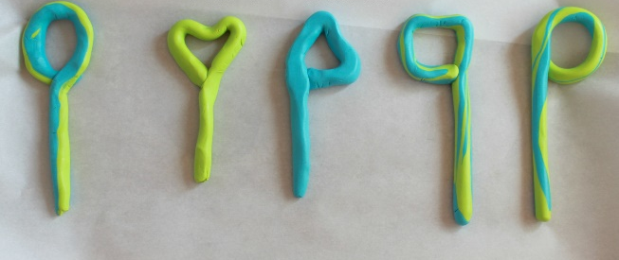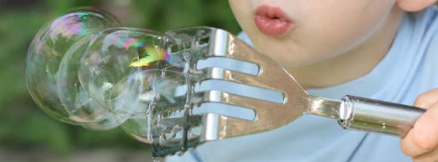

Bricks; give your child one brick from the box and wait for an attempt at “more” before giving the next one.

Balloons; blow up a little bit, then wait for your child to attempt “more” before continuing.

Pretend to make mistakes; put the wrong piece in a puzzle or

try to post the wrong piece in a shape sorter and encourage your child to say “no”.

Hiding; hide small, interesting toys in your hands and ask your child to guess which hand it is in. Keep it fun, saying “oh no!” or “oh dear” if your child guesses the wrong hand.

Lift-the-flaps books; as you lift a flap, ask “is it Spot?” then answer “Oh no. It’s the cat”

Repetitive games: play any repetitive game, but give your

child a chance to say “again” in between turns.

e.g. peek a boo. hiding and re-appearing from behind a chair or under a scarf.

Roll a ball 