Manners at school

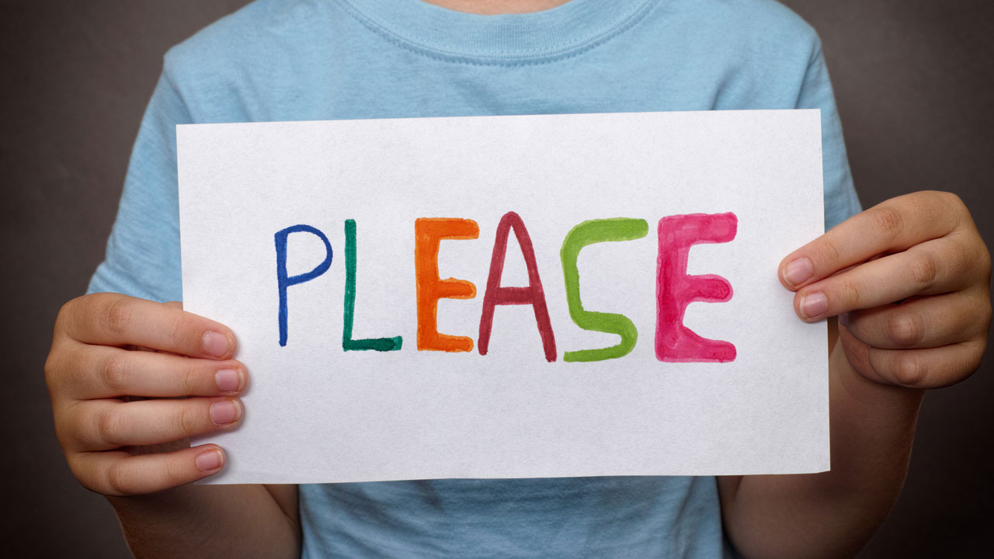

Using polite words – please, thank you,

excuse me

<http://bit.ly/28UqWhD>

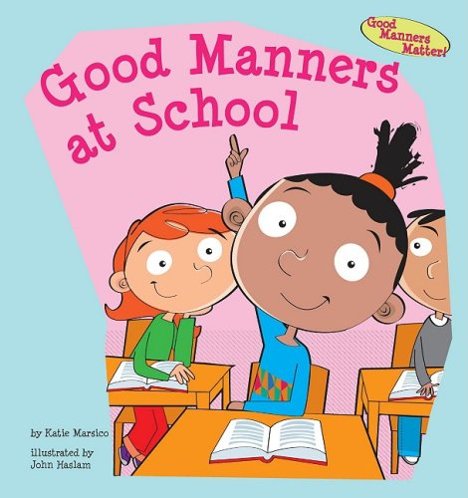

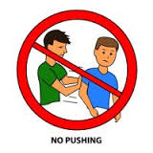

**Keeping your hands to yourself**

<http://bit.ly/2njQp7k>

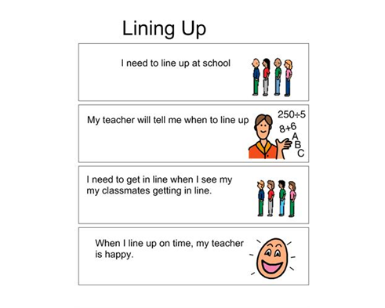

**Free Social Story Book- Class rules**

<http://bit.ly/2mFMcO8>

**No dummy at School**

Try SuperNanny ‘Dummy Fairy’ approach

<http://bit.ly/2mLUNPU>

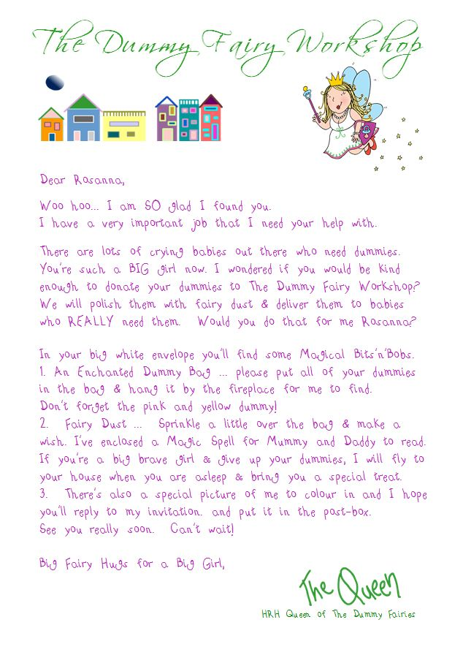

**Feeling angry and saying ‘sorry’**

<http://bit.ly/2n4DQ3t>



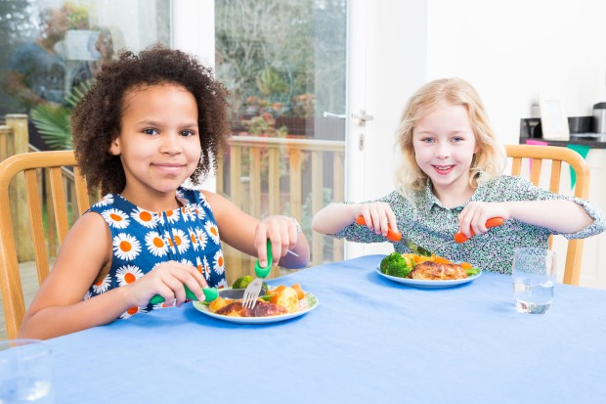

**Cutting up own food**

See cutlery sheet

**Using a tissue**

See nose blowing sheet

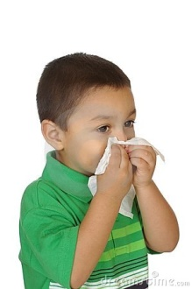

Newbridge Outreach Service [www.redbridgeserc.org](http://www.redbridgeserc.org) www.redbridgeserc.org