Hands & fingers

CYLINDRICAL/PALMAR  (1-1 ½ YRS) | DIGITAL  (2-3YRS) | MODIFIED TRIPOD  (3 ½ -4 YRS) | TRIPOD  4 ½ YRS-7YRS)
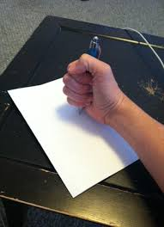 | 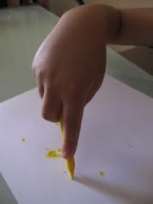 | 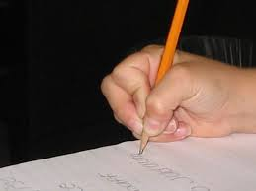 | 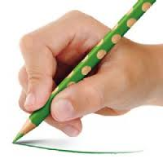
THUMB WRAP | TRIPOD CLOSED WEBSPACE | THUMB TUCK | DIGITAL PRONATED
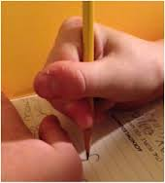 | 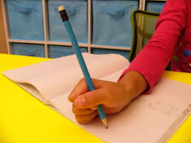 | 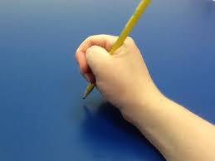 | 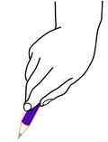

FINGER ISOLATION | 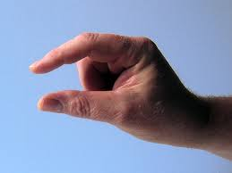 | Touch thumb, finger 1, finger 2, finger 3, finger 4 etc
OPEN WEBSPACE | 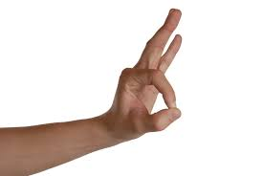 | Make ‘OK’ sign  Popping activities eg bubble wrap, cereal
ARCHES DEVELOPED | 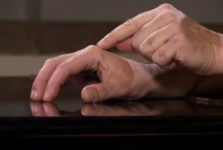 | Cup hands to shake a dice  Make a spider shape on the table
THUMB OPPOSITION | 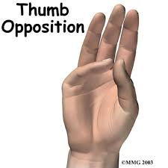 | Thumb reach across to touch each finger.

Sitting positions
Leans to one side | Holds onto to chair edge
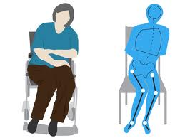

Leans on table top | Correct sitting position
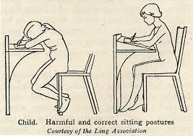 | 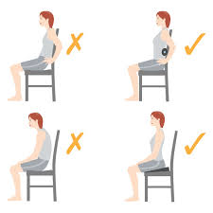
Laying back in chair | Hunch
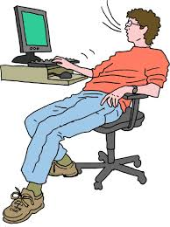 | 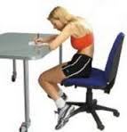
Cross legged sitting
