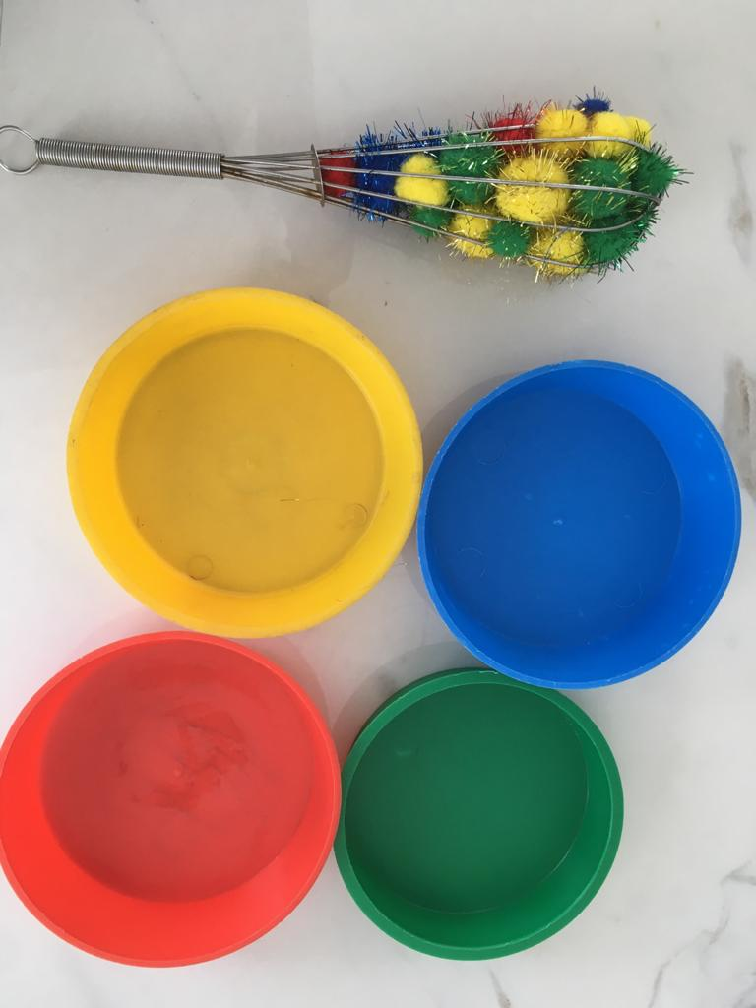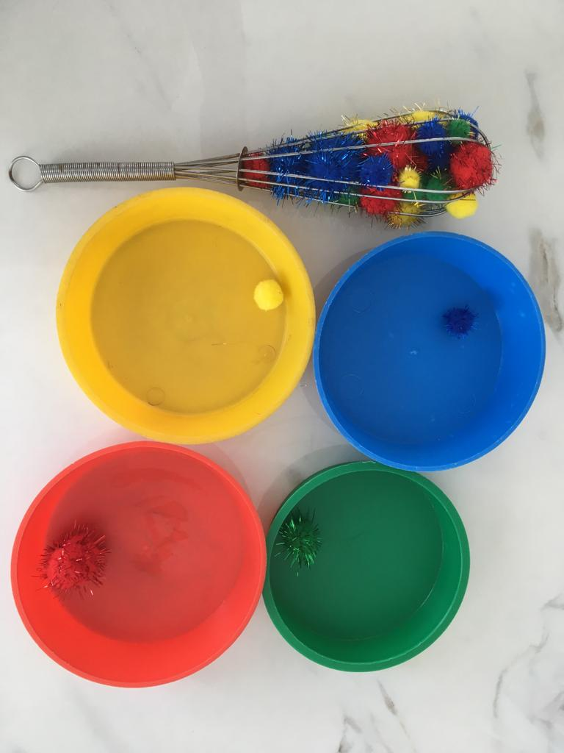

4 coloured pots or cups, a whisk and 4 lots of different coloured pompoms, to match the pots.

Put all the pompoms into the whisk.

Get your child to remove the pompoms and put each pompom into the correct coloured bowl.

You can get the children to put the pompoms back into the whisk.

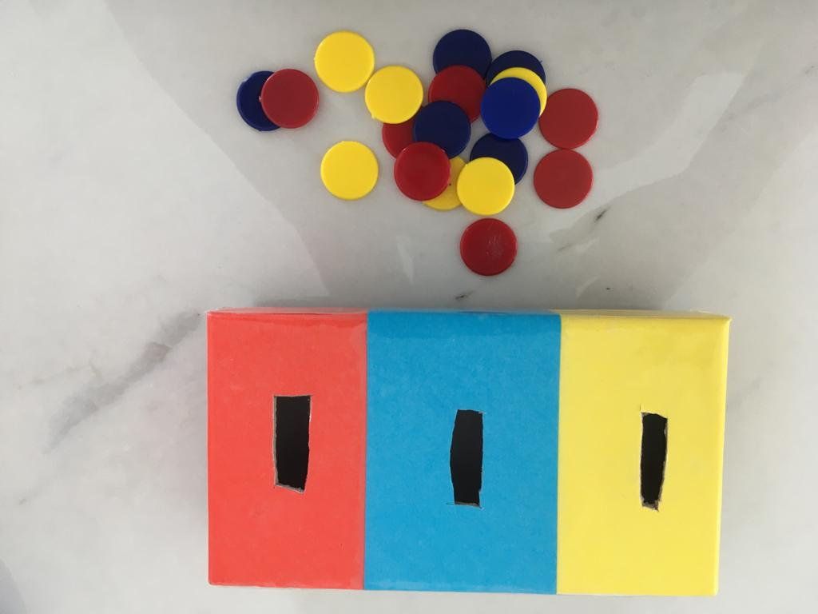 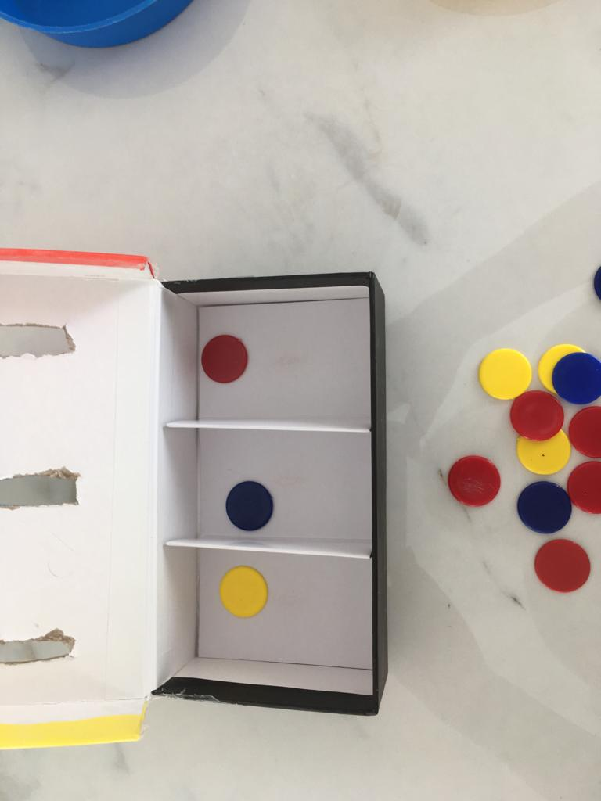

Get a box and divide the inside into 3 compartments.

Stick 3 different coloured papers on top of the box.

Make a slit in each colour.

Ask children to put correct counter into the correct colour slit.

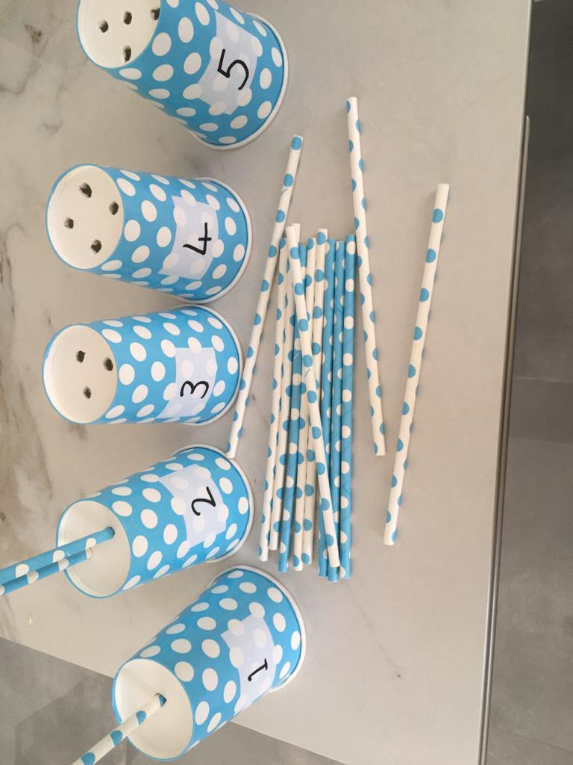

Get 5 party cups, and 15 straws.

Stick numbers 1 to 5 on the cups.

Make one hole in the number 1 cup, 2 holes in the number 2 cup, 3 in the number 3 cup, 4 in the ‘4’ cup and 5 in the ‘5’ cup.

Ask your child to put the straws in the holes