Outdoor Play
Even though we are encouraged to stay at home at the moment the weather is lovely and opportunities for fresh air are important for us all.

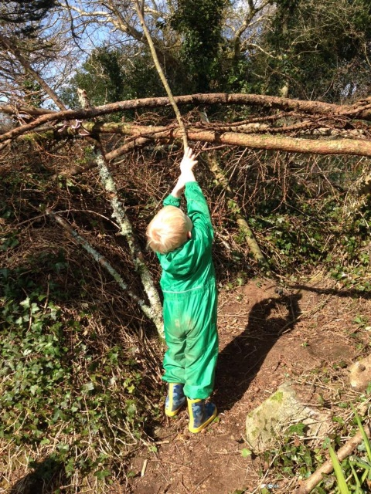
Walking:
Try to schedule a walk into your day.
This will enable you and your child
to get fresh air, enjoy a change of
scenery and let of steam!
You could collect leaves or pine cones
along the way.
Remember socially distancing if you
are out and about.

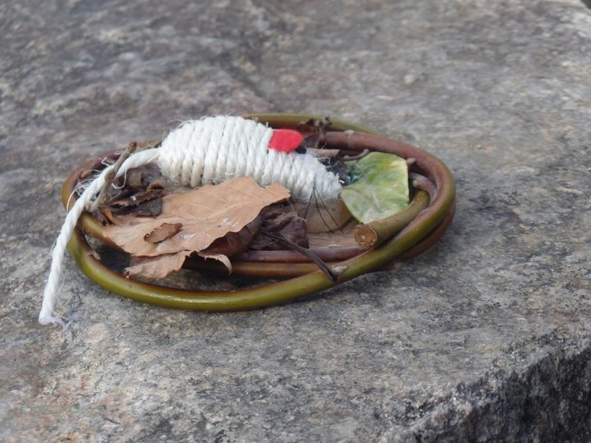
Treasure Hunt
Hide some brightly coloured
toys around the garden and
ask your little one to see if
they can find them. Don’t
make it too tricky or your
finder may lose interest.

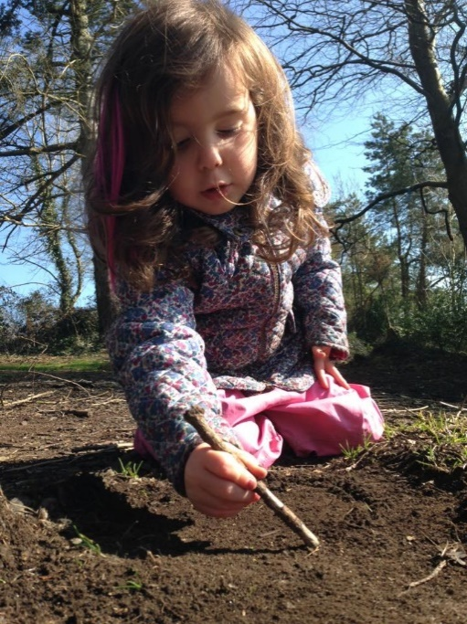

Drawing with sticks
Draw shapes in the dirt with sticks.
Use sticks and twigs to draw shapes
in the dirt. Fun and a good way to
encourage early mark making.

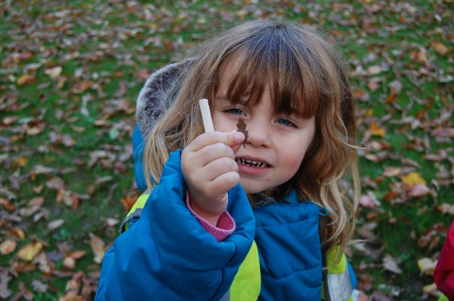
Sensory exploration
Feel the bark, the leaves, the
grass – how does it feel? Is it
rough or smooth? Soft or hard?
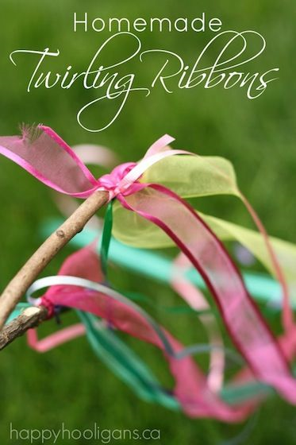
Twirling Ribbons
Make your own twirling ribbon sticks
by collecting sticks and tying ribbons
securely to one end. Your little one
will have a wonderful time watching
the ribbons blow around in the
breeze as they wave them in the air.

