Play dough
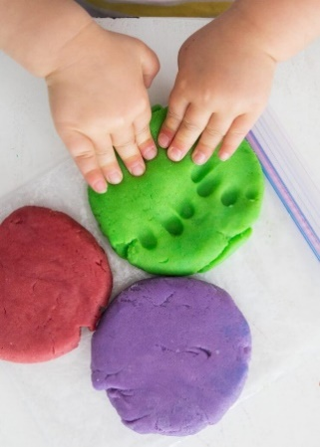
Play dough is a sensory activity that promotes play and allows children to slow down and have fun while using their creativity and imagination.
Playing with playdough is soothing and calming even for adults! It’s a fun way to ease tension, release extra energy, improve focus and concentration and a great outlet for emotions and releasing anxiety.
Squeezing, pulling, poking, prodding and rolling play dough is perfect for strengthening the muscles in little hands. The same muscles they will use later to hold a pencil, cut, and do up buttons.
Spending time with your child making and playing with playdough also encourages their language, social skills, science and maths all at the same time!
Simple play dough recipe
- 250g plain flour
- 50g salt
- 140ml water
- 1 - 2 tablespoons of cooking oil
- Few drops of food colouring (optional)

Preparation method
1. Mix together the flour and salt in a large mixing bowl. Add the water and oil.
2.Knead well until mixture is smooth about 10 mins. You might need to add a bit more flour or water until the consistency is smooth but not sticky.
3.Add food colouring and knead until the colour is fully blended.
4.Store in a plastic bag in the refrigerator until chilled enough to use.
For alternative recipes see below
For baking
https://www.youtube.com/watch?v=oAIAm6BF0fs&list=RDCMUCGbxOeCBuGSsKvt4g9lEv3A&index=1
Salt free
https://www.google.com/search?q=salt+free+playdough+recipe+uk&rlz=1C1GCEA_enGB779GB779&oq=salt+free+play+doh+recipes&aqs=chrome.2.69i57j0l2.11192j0j8&sourceid=chrome&ie=UTF-8
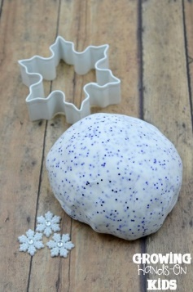
You can also add the following
- herbs (mint, rosemary, lavender that you may have growing in your garden),
- spices (ground ginger, mixed spice) that you may find in your cupboards
- glitter, sand to add texture
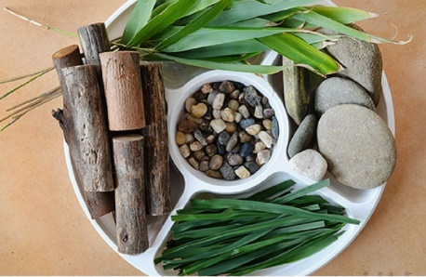
- natural materials like twigs and leaves
Playdough activities
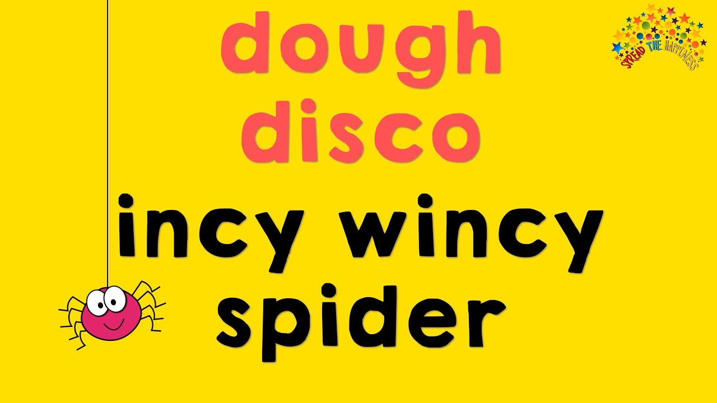
https://www.youtube.com/watch?v=KSBO8N4ctJg
Collect items from around the house and add them to the play
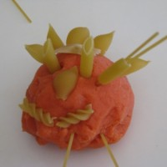
- Birthday candles, blocks, bottle tops, straws, cookie cutters, plastic knives and forks, large buttons and other objects that can be pressed into the dough to create patterns or add features, small world people/animals, dried pasta, baking trays, potato masher, garlic press (be prepared to give it up forever).
If your child has a particular interest you can collect specific resources to support these (see examples below)
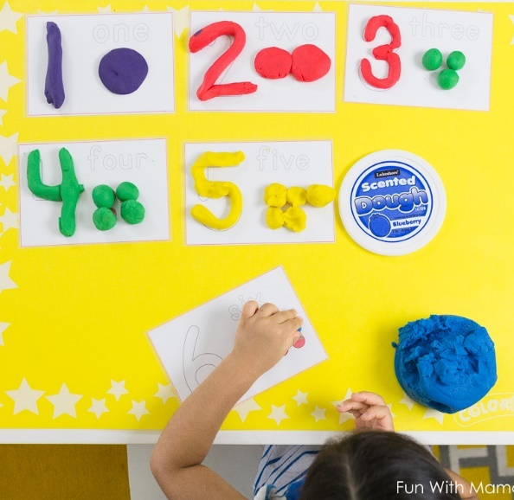
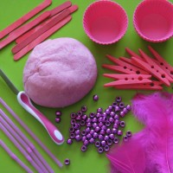

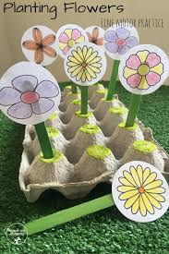

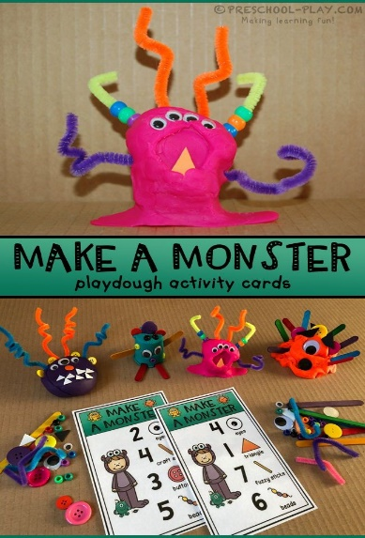
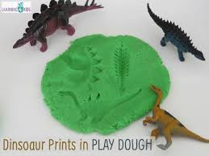

There are loads more ideas on Google, Pinterest and YouTube

Have Fun

