Rub hands on legs Chewing Stretch and relax muscles –Yoga

Give yourself a hug Bumpy cushion

Chewing

Bumpy cushion

Standing tables

Balance balls

Resistance bands

Heavy work activities

Fidget toys

Activate the vestibular nerve

Movement breaks

Active school day

**YES**

Proprioception activities

Shoulder/arm activities

Core Stability activities

Balance ball activities

**NO**

**Is the student very mobile in their seat?**

**YES**

**Is the student sitting poorly in their seat?**

**Classroom position**

Do they have to turn to see the board?

Are they next to wall?

Is there room around their chair?

**Core stability/Trunk control**

**Proprioception**

**Shoulder /arm strength**

Change table/chairs if possible

Good sitting visual prompt cards

**YES**

Try seat wedge 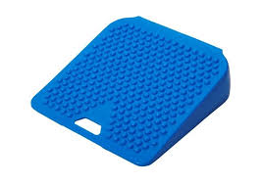

**NO**

If the chair is too high…try a foot block.

**Is the student sitting at correct sized table/chair?**

Ensure they can put their feet flat and bottom back in the chair

**poor sitting positions**