

Sitting – are your feet flat?

* is your bottom back?
* is your back straight?

Close your eyes and rotate shoulders

– forwards

* backwards
* shrug your shoulders fast and slowly

Shake your arms and hands down by your sides/ up in the air.

Palms together- fingers spread and pressed together.

Push elbows out and heels of hands down x 5.

Fingers interlaced- stretch arms out in front.

Push palms of hands forward away from body x 5.

Arms down by sides.

Grip and release hands.

Shake hands down by sides.

Relax- sit back in chair, drop head, close eyes, concentrate upon breathing (while their eyes are shut place a sticker and homework in front of them).

End session.

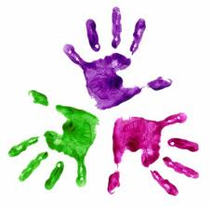



**Relaxation routine**

Healthy Hands