|  |  |  |  |  |  |
| --- | --- | --- | --- | --- | --- |
| **Visual Impairment Edition** |  | |  | | --- | | SERC Newsletter  February 2010 | |  | |  | |
|  |  |  |
| www.redbridgeserc.org |  | TEl: 0208 503 8773 |

**Mental Health Week 5t February 2019**

There are range of free resources to support you this week in Schools and throughout the year.

Anna Freud Centre have great School resources that are free;

<https://bit.ly/2HTBfVq>

Lesson plans, Assembly ideas, Animation films etc

Through SERC, some of the Schools in Redbridge are currently trialing a new App

designed by the Anna Freud Centre, aimed to support Mental Health/ Wellbeing

in Students who have SEND.

We will feedback in the summer term when the results are in.

**Disabled Emoji’s coming in the Spring**



**International Tube Feeding Week 4th Feb**

One Mum in Glasgow is currently

making Teddies with Tubes

[**https://bbc.in/2t4Q11l**](https://bbc.in/2t4Q11l)

What a good idea – looks fairly

easy to do

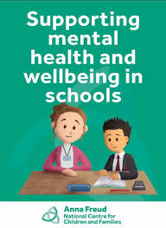

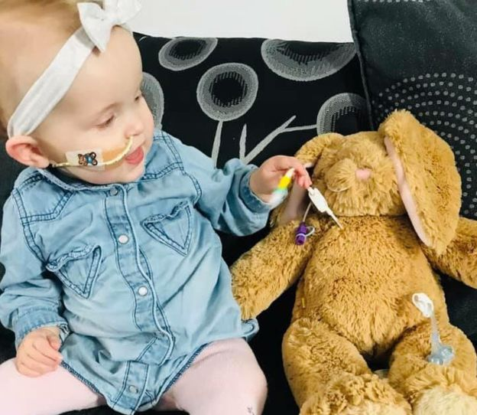

**Improvise Music**

A unique way of accessing music for Students who have a range of SEN/ PMLD challenges

<https://www.improviseapproach.com/free-songs-to-download>

Great free resource for all staff working with complex Students

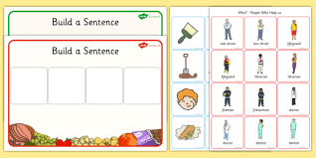

**Twinkl** is a heavily used website by Educational Professionals

They have recently added some great new Colourful Semantics Resources – they will save you hours of preparation time. They also will add variety for those students becoming bored with repetition.

### **General Info**

**FREE TYPING WEBSITE**

[**https://www.typingclub.com/**](https://www.typingclub.com/)



**The Truth about CAMHS**

Take 5 minutes to read…. Here is an Anonymous Post in TES, written by a CAMHS worker

<https://www.tes.com/news/truth-about-camhs-and-five-things-schools-can-do>

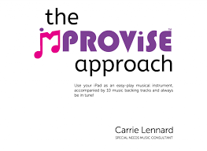



**PARENT’S PAGE**

**Muscular Dystrophy UK** have recently launched a

free online training course for GP’s, Physio’s and OT’s.

If you find the professional supporting your child with

MD, has little knowledge or awareness, please share

this new great training resource for Health Professionals.

<https://bit.ly/2Dj3cRc>

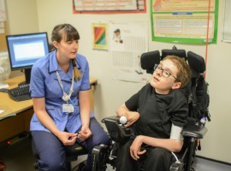

**Financial Help for Families**

We have a section on the website outlining the charities that will help support a variety of needs.

<http://redbridgeserc.org/resources/category/grants-financial-support>



The Family Fund is the latest Charity helping families of disabled children

<https://www.familyfund.org.uk/>

Skiggle is a fantastic Website /Facebook page – designed for Parents/ Carers who have an excess of consumables that can be recycled and shared with other families

They also have a SOS not for profit marketplace where families can sell specific equipment/ resources or place an SOS as see if another family can help you out.

.

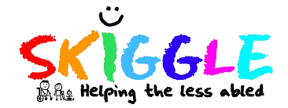

|  |  |
| --- | --- |
| **VAT excemption scheme**    Did you know if you are buying specific equipment, you may be able to claim back the VAT (20%)?  <https://bit.ly/2BpYUXM> |  |
|  |

**The Willow Foundation**

[**https://www.willowfoundation.org.uk/Home**](https://www.willowfoundation.org.uk/Home)

Charity set up to provide special days out for people aged 16-40 yrs who have a serious illness or a degenerative condition.



**SENCO PAGE**

**Bereavement**

**Did you know 1 in 25 children will experience the death of a sibling or Parent while in Education?**

Be prepared- we have a section on the website with links and information..

<http://redbridgeserc.org/resources/category/bereavement>

I also have seen recently **The Invisible String** book being used in a school- great book; you can watch it free on You Tube



**Downs Syndrome.org** offer Online Training courses

Each course has a specific cost, which enables you to purchase what you need eg Behaviour

<https://bit.ly/2HUMo8k>

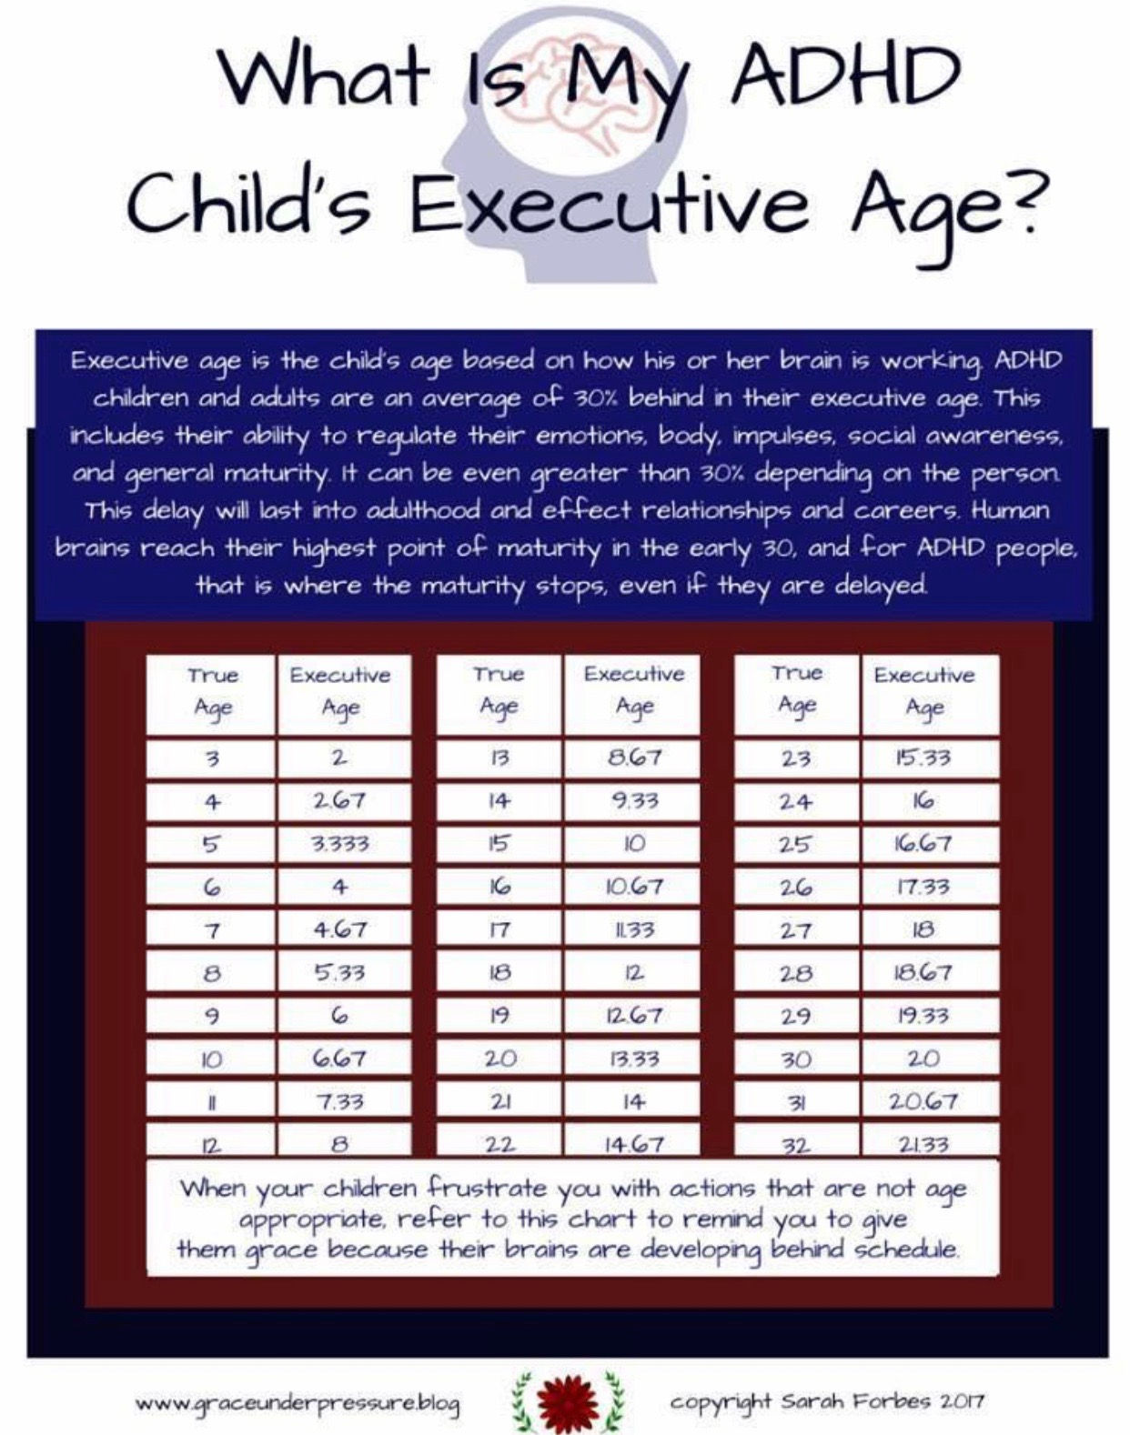

**Unique Art Awards**

<http://www.uniqueartawards.uk/>

Competition is open to Students aged 7-21yrs –prizes include £600 for Student and £3000 for School.

What a great way of an SEND student representing your School/ themselves!

